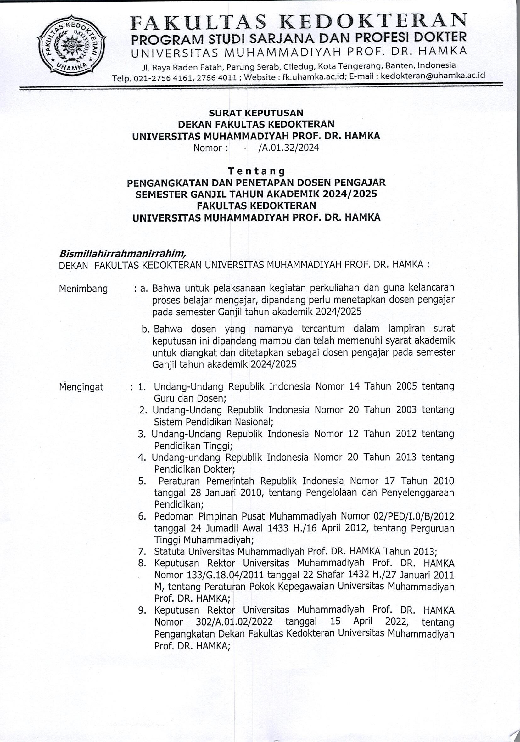
110

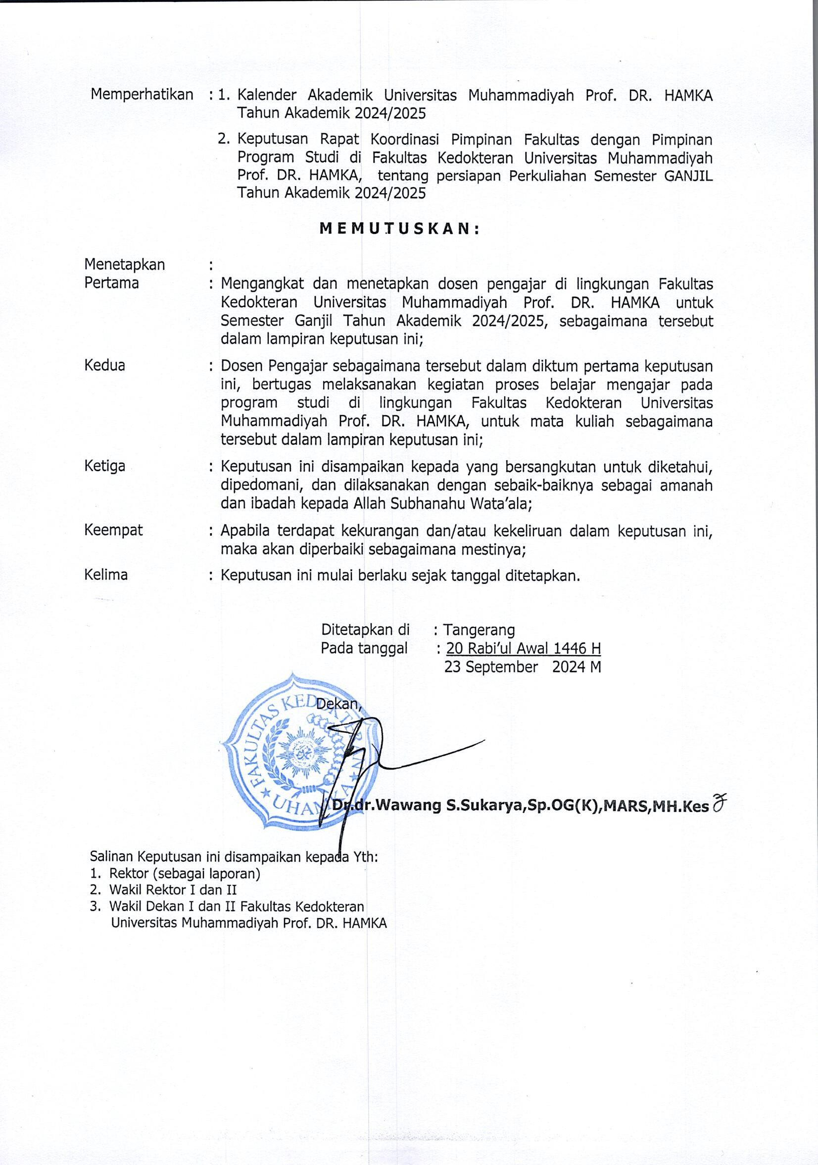

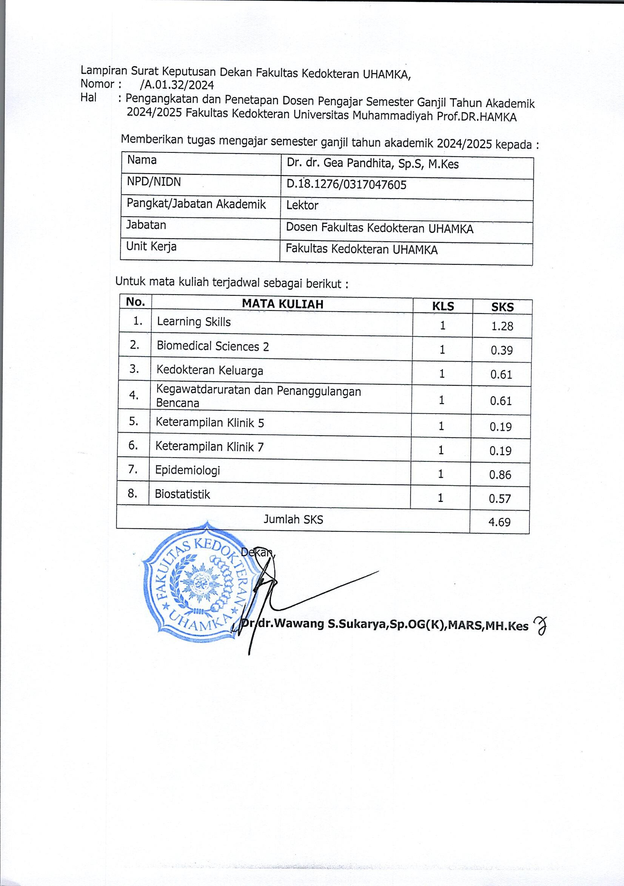

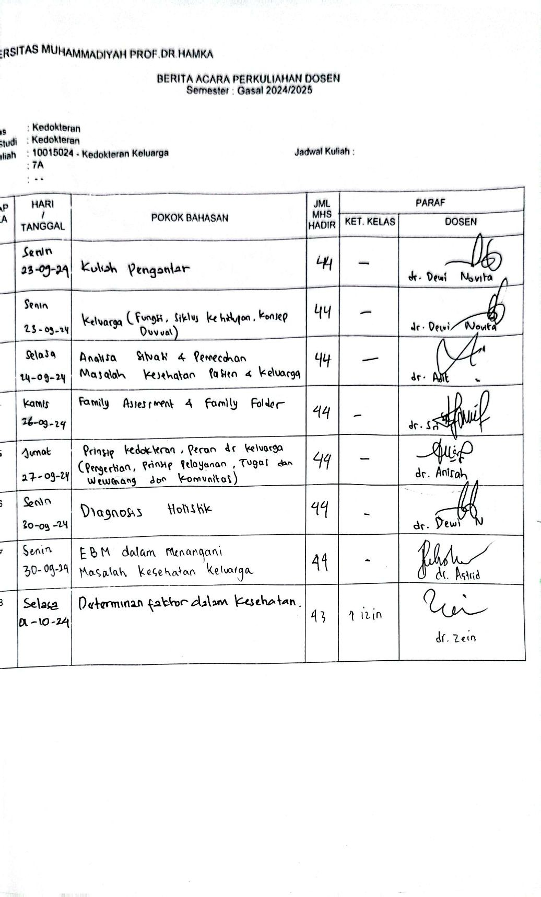

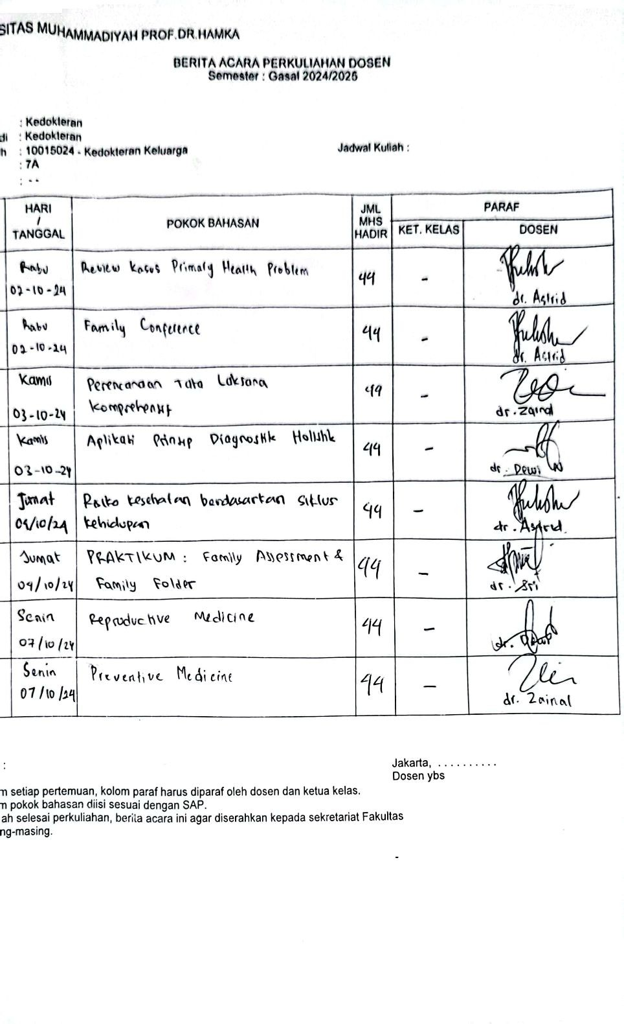

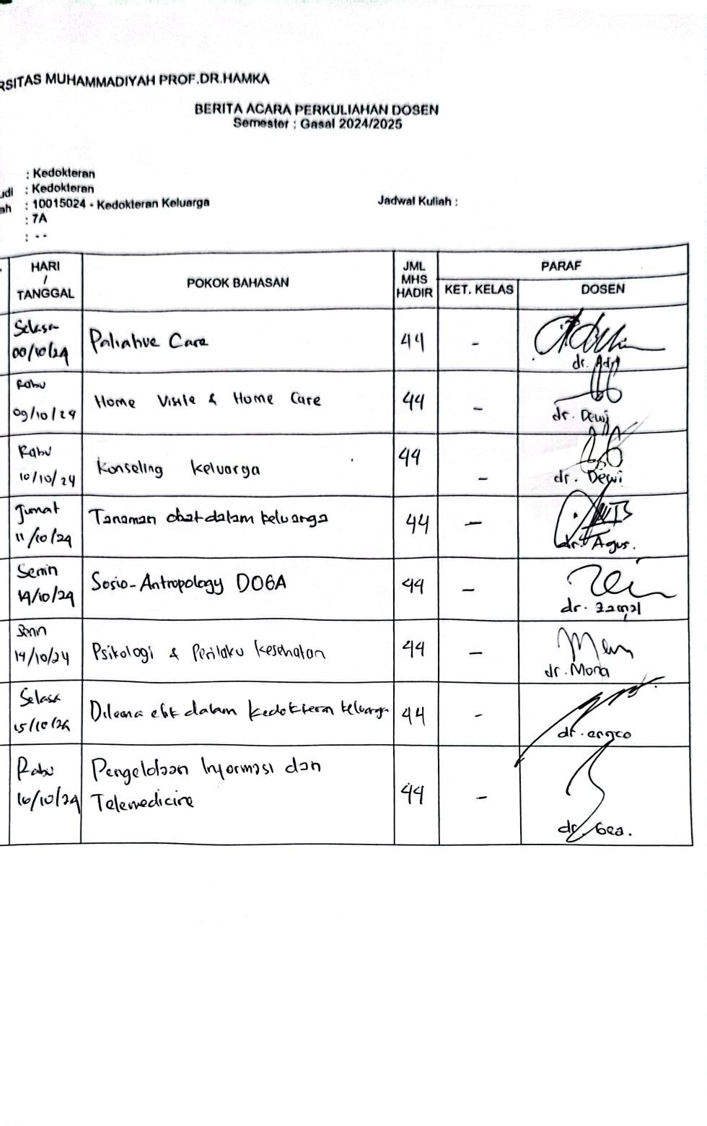

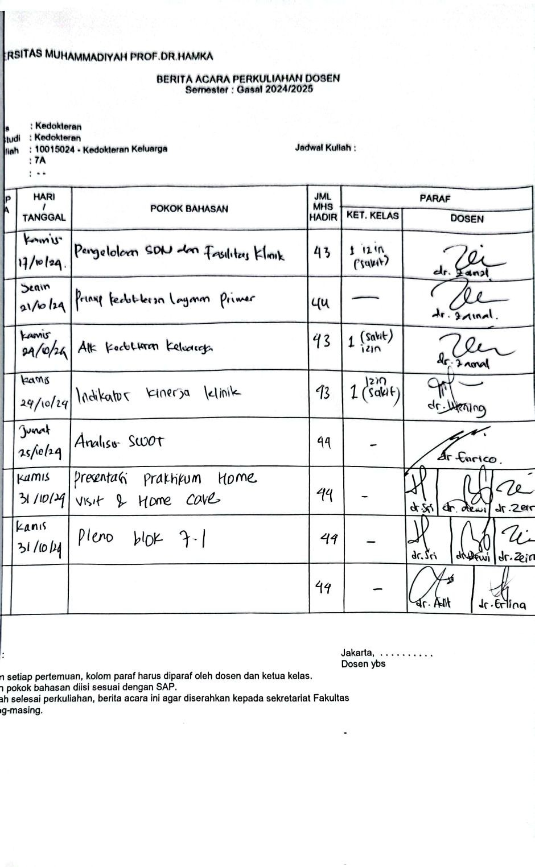

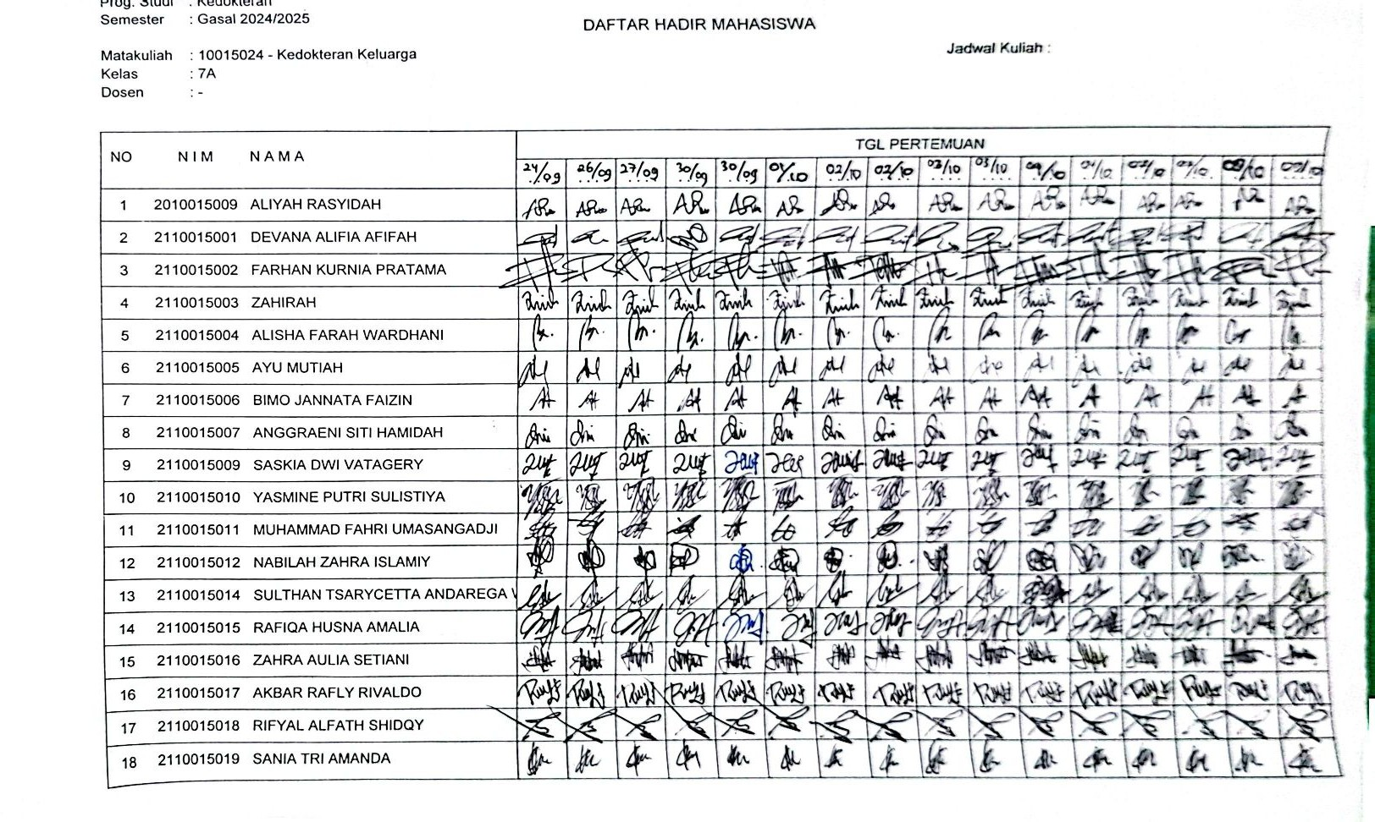

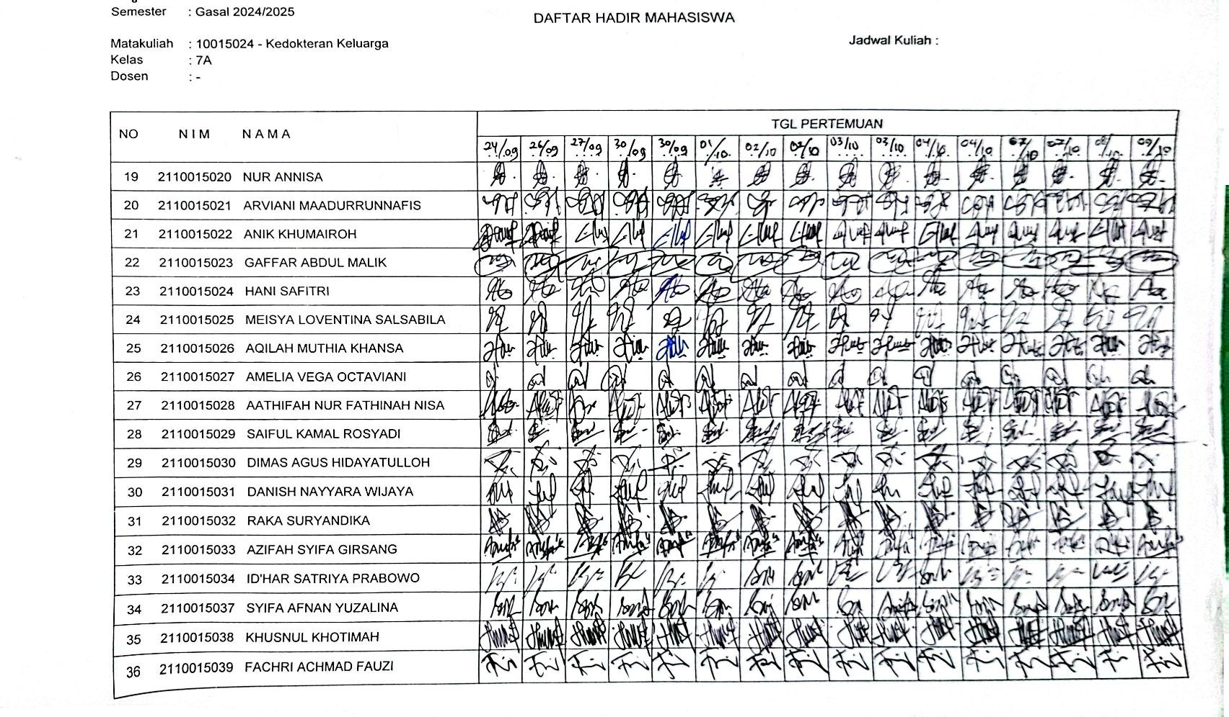

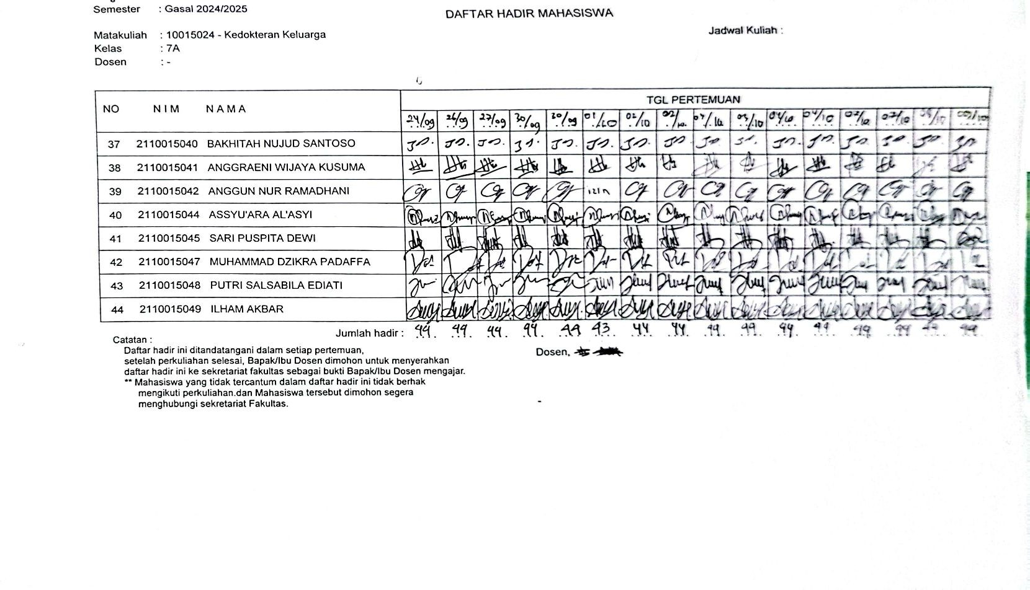

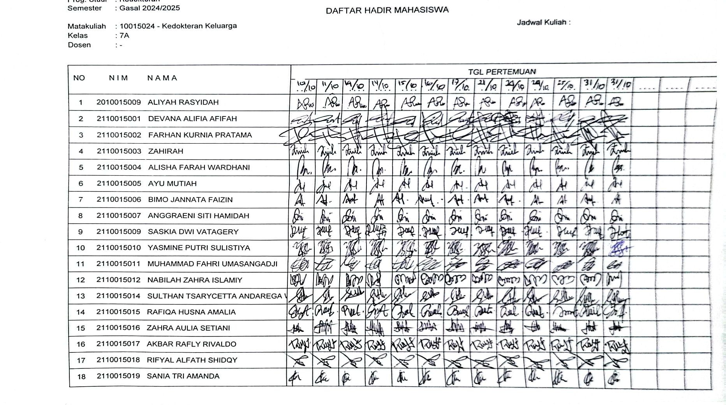

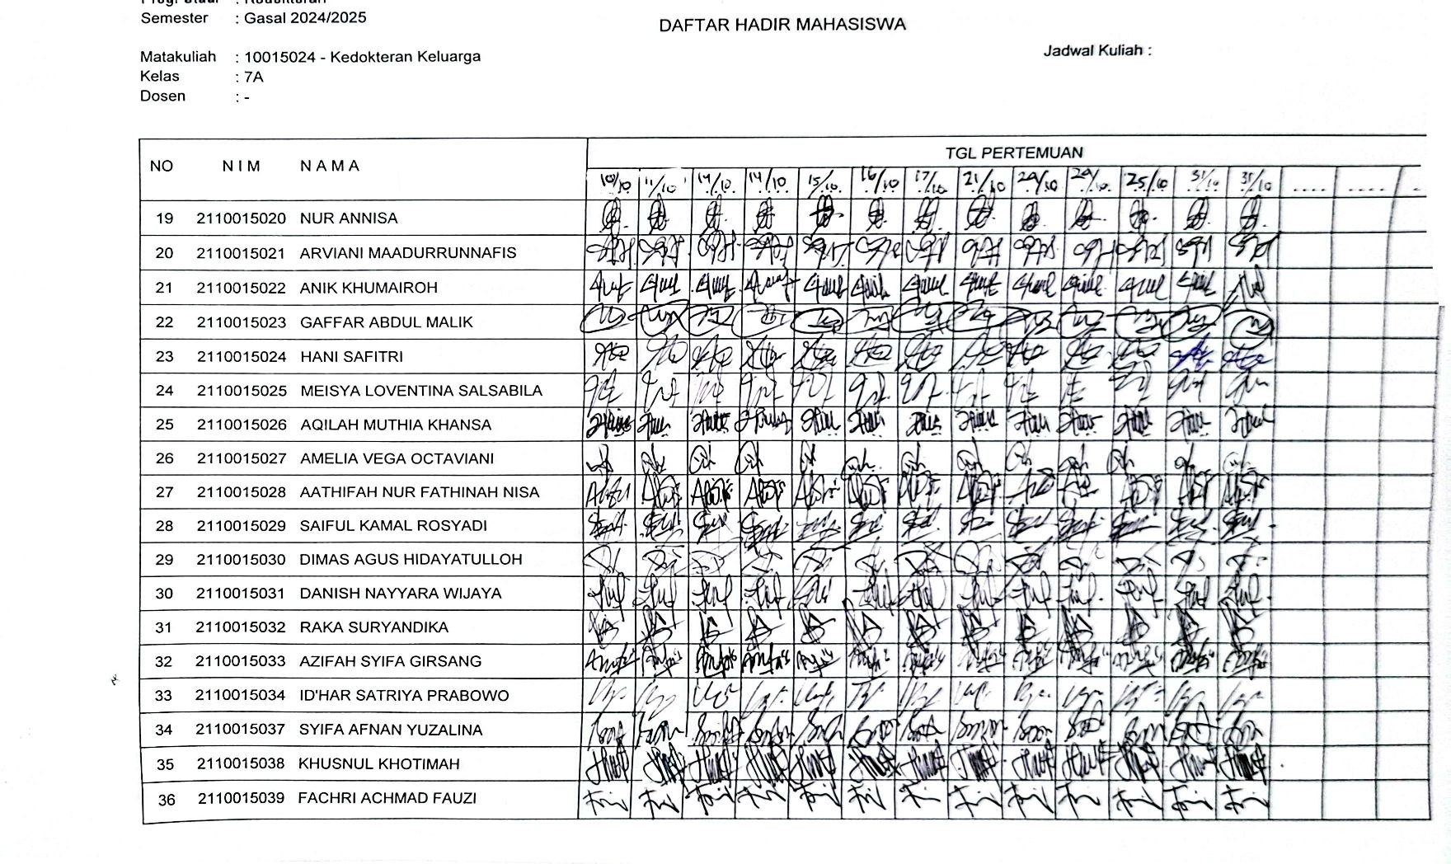

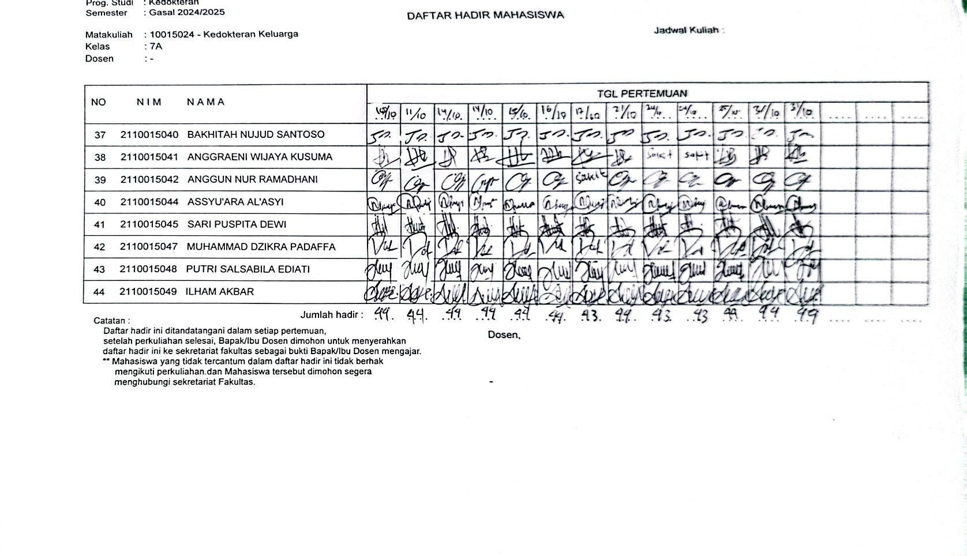

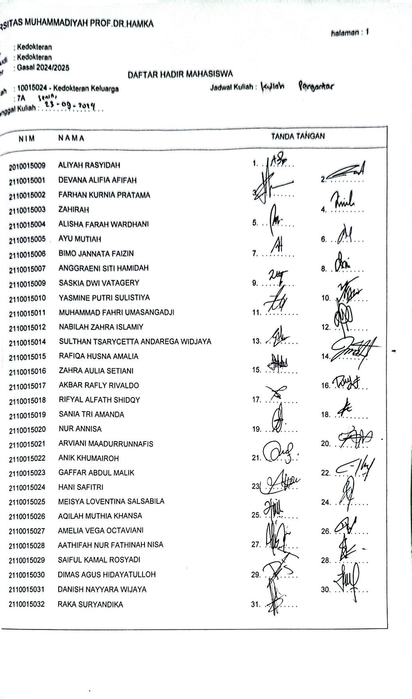

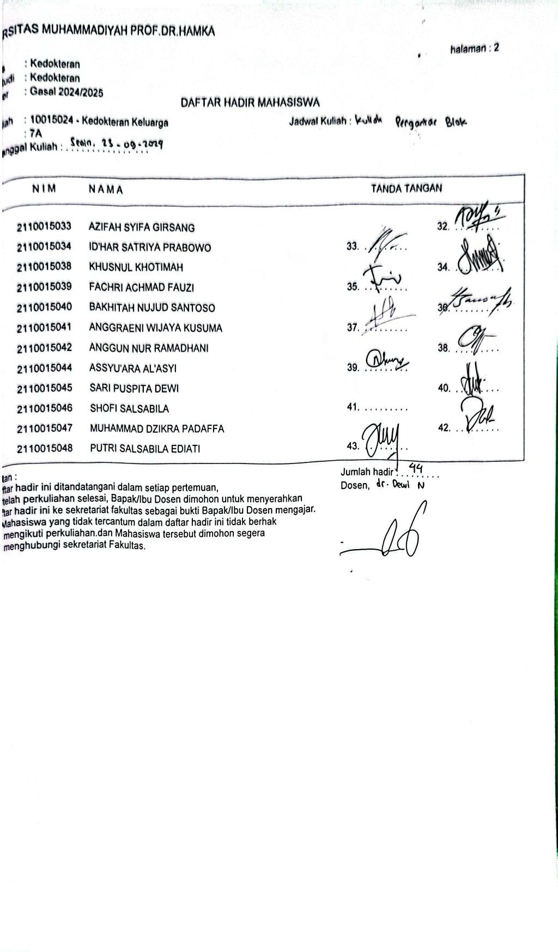

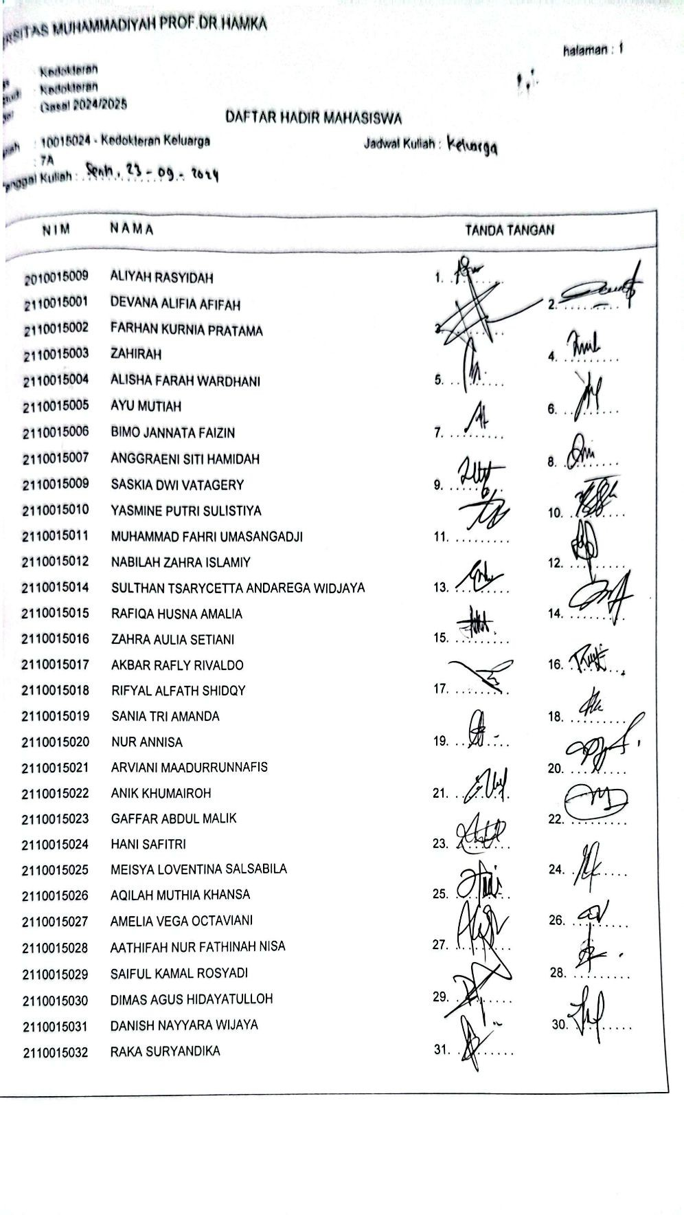

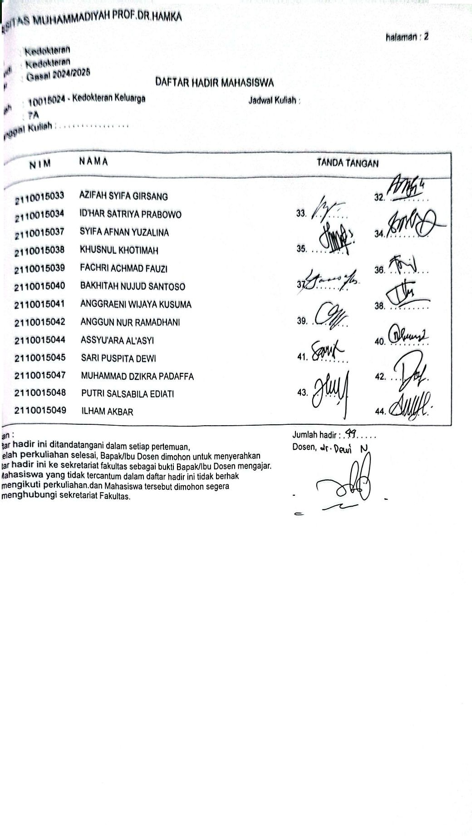

Nama Depan | Nama akhir | NIM | Nilai/100
BIMO | JANNATA FAIZIN | 2110015006 | 78
GAFFAR | ABDUL MALIK | 2110015023 | 78
AATHIFAH | NUR FATHINAH NISA | 2110015028 | 75
Ilham | Akbar | 2110015049 | 63
NABILAH | ZAHRA ISLAMIY | 2110015012 | 74
FACHRI | ACHMAD FAUZI | 2110015039 | 65
MEISYA | LOVENTINA SALSABILA | 2110015025 | 76
ALIYAH | RASYIDAH | 2010015009 | 65
SYIFA | AFNAN YUZALINA | 2110015037 | 66
AKBAR | RAFLY RIVALDO | 2110015017 | 66
KHUSNUL | KHOTIMAH | 2110015038 | 74
AYU | MUTIAH | 2110015005 | 68
AMELIA | VEGA OCTAVIANI | 2110015027 | 75
BAKHITAH | NUJUD SANTOSO | 2110015040 | 74
SARI | PUSPITA DEWI | 2110015045 | 72
MUHAMMAD | FAHRI UMASANGADJI | 2110015011 | 73
RAFIQA | HUSNA AMALIA | 2110015015 | 73
SANIA | TRI AMANDA | 2110015019 | 79
RIFYAL | SHIDQY | 2110015018 | 68
RAKA | SURYANDIKA | 2110015032 | 64
PUTRI | SALSABILA EDIATI | 2110015048 | 67
DIMAS | AGUS HIDAYATULLOH | 2110015030 | 69
ZAHRA | AULIA SETIANI | 2110015016 | 71
AZIFAH | SYIFA GIRSANG | 2110015033 | 81
NUR | ANNISA | 2110015020 | 77
MUHAMMAD | DZIKRA PADAFFA | 2110015047 | 66
SAIFUL | KAMAL ROSYADI | 2110015029 | 78
HANI | SAFITRI | 2110015024 | 80
ZAHIRAH | ZAHIRAH | 2110015003 | 68
DEVANA | ALIFIA AFIFAH | 2110015001 | 66
DANISH | NAYYARA WIJAYA | 2110015031 | 76
FARHAN | KURNIA PRATAMA | 2110015002 | 66
ARVIANI | MAADURRUNNAFIS | 2110015021 | 72
SULTHAN | TSARYCETTA ANDAREGA WIDJAYA | 2110015014 | 66
ANGGRAENI | WIJAYA KUSUMA | 2110015041 | 68
ASSYU'ARA | AL'ASYI | 2110015044 | 71
YASMINE | PUTRI SULISTIYA | 2110015010 | 81
ANGGRAENI | SITI HAMIDAH | 2110015007 | 65
ANIK | KHUMAIROH | 2110015022 | 74
AQILAH | MUTHIA KHANSA | 2110015026 | 67
ALISHA | FARAH WARDHANI | 2110015004 | 70
SASKIA | DWI VATAGERY | 2110015009 | 73
ANGGUN | NUR RAMADHANI | 2110015042 | 64
ID'HAR | SATRIYA PRABOWO | 2110015034 | 70
 | Rata-rata keseluruhan |  | 71

