Environmental, Social and Governance Performance: A Bibliometric Analysis

Ummu Salma Al Azizah and Razali Haron

Abstract. The current paradigm on sustainability leads to comprehensive understanding of Islamic Sustainable Finance (ISF) based on the objectives of Maqasid sharia. This study analyses the Environmental, Social and Governance (ESG) performance as part of sustainable finance by applying a bibliometric analysis of documents published. Bibliometric study shows the patterns of the previous studies related on the topic. Total data collected form the Scopus database was 386 articles from 2017 to 2022, with the sources keywords on ESG and performance. By using Vos-viewer for bibliometric analysis, the content of articles can be observed to mapping the previous and future studies. The study mentioned that there was six cluster related to the paper’s topic on ESG performance. To the best of our knowledge, there is limited analyses on the bibliometric for this focus field. This study also provided some relevant information regarding the publisher, journal and authors on ESG performance. This study provides current trends of the research paper on ESG performance, and enable future researcher to examined the future research directions, with key findings on corporate financial performance.
Keywords: Islamic sustainable finance, ESG performance, Vos-Viewer

- Introduction

Sustainable development is related to company’s resources or economy’s resources as a long-term strategic decision by business firms. With the concept that incorporates the needs of the present without compromising the ability of future generations to meet their own needs. Sustainability refers to the maintain of a phenomenon for some specification for the future. It is implied a linear continuity of the growth and presents as a foreseeable future. Therefore, corporate sustainability measured the impact firms’ policies in the area of economic, environmental, social and governance have on the society. There was an increasing shareholders’ economic and business firm use this responsibility as an objective to gain the profit maximization (Friedman, 1970).
Sustainable development within the Islamic paradigm can be defined as follows:
“Recognizing the complementary nature of all the stakeholders to reach unity (tawhid) within the balance (mizan), which requires the recognition and provision of an opportunity space for the given (fitra) development path for each stakeholder to reach their perfection, where the growth of each stakeholder has to be in harmony with other stakeholders’ leading to inter-and-intra generational justice (adalah) through the actualization of equilibrium-based (ihsani) governance”.
Islamic finance plays an important role supporting the concept of sustainable finance which is involved fairness, mobilizing the domestic resources and social welfare. In addition, Islamic finance is proposed as an alternative to conventional finance to pursue economic sustainability through instruments with different economic impacts. Therefore, there is correlation between performance and economic sustainability of Islamic finance is through sustainability practices (Brescia et al., 2021).
The principle of Environmental, Social and Governance (ESG) concept resulted after the World War II at 1960s which is have an environmental issue. There were the changes in the global world and shifted to the sustainable development on the industrialization and business model. Specifically, ESG criteria have an aspect driven forced the company’s performance of sustainability with the focus on three pillars as such environmental, social and governance. In addition, after the global of financial crises, managers around the world reform their governance and implemented the sustainable performance. According to Landi et all., (2018), the better ESG performance of the companies are proved the high financial performance and being sustainable.
Many organizations in the international level have been developed the various frameworks an ESG disclosure with the current issues. The organizations such as Carbon Disclosure Project (CDP), Global Reporting Initiative (GRI), International Integrated Reporting Council (IIRC), Sustainability Accounting Standards Board (SASB) and United Nations Global Compact (UNGC). They provided the clear guidance on the ESG reporting and identification the best performance for corporate social responsibility and environmental responsibilities. In addition to this, the extensive indicators on ESG that are described by major rate providers such as Morgan Stanley Capital International (MSCI), Bloomberg, and Refinitiv.
Previous research suggests that greater ESG ratings have lower related firm-specific volatility and downside tail risk during the first year of trading in the aftermarket, and that ESG disclosure and risk in initial public offering (IPO) are reducing the volatility and downside tail risk. (B Reber et al., 2021). In the context of the current Environmental, Social, and Governance agenda, further criteria for better corporate governance procedures to benefit investors are advocated. The study on the Russian electric power industry (Sheveleva, 2022) Provided updated guidance from the Bank of Russia on the disclosure of non-financial data, the board of directors' assessment of ESG concerns, and the reports on conformity with the tenets and guidelines of the corporate governance code.
The aim of this study is to conduct quantitative bibliometric analysis on ESG performance including the authors, citations, journal and publisher. Researchers identifying and examining the organization of a certain study field using bibliometric analysis. The goal of using bibliometric analysis was to depict the collaboration patterns in papers, journals, publishers, and writers in order to identify developing trends in a particular field, which broadens the perspective of research (Miguel-Molina et al., 2021). Therefore, the main objective of this paper is to review the existing studies on the relationship of ESG performance mechanism and to suggest opportunities for future research agenda in this field.
Bibliometric analysis considered to address the following questions: 1) what are the most leading of literature such as publishers, journals, authors and articles? 2) what are the keywords used? 3) what are the main clusters in the literature of ESG performance? 4) what are the relevant future research questions from the trending articles in the literature? Therefore, in order to answers all questions, introduction will be as the first section, followed by section 2 which explain generally about ESG performance and bibliometric analysis. The next section methodology and section 4, results and discussion. Then, last but not least, Conclusion, limitation and future agenda in section 5 and 6. This article is intended to pique the interest of investors interested in the essence and significance of ESG performance, such as enterprises, governments, financial institutions, and academic organizations. Similarly, this article provided new insight into ESG performance and was utilized as an advice and promotion tool for organizations.

- Literature Review
Islamic finance is closed into the relationship between financial flows and productivity. There is proper checks and controls for linked into the economic growth. However, Islamic sustainable finance as a practice of sustainable finance and business model with the profit and loss sharing based. Furthermore, income distribution, social and environmental activities as a principle of Islamic finance leads to the development of Islamic financial system which is relevant with the SDGs targets.
Environmental, social, and governance (ESG) is a prominent word used by a group of investors to be conscious of the worthy factors in CSR linked functionality on the company's variable. The notion of environmental, social, and governance (ESG) has been around since the 1950s, but it only became a real issue in the 2010s. ESG has three dimensions: environment, social, and governance. There has been an increase in external pressure on firms to change their behavior and focus on ESG factor integration into their business activities.
Governance (G) is the most important of the three parts of ESG. Governance risks are the same and important for all companies, but environmental and social risks aren't always as important. A lot of people are interested in climate finance, and governments, regulators, security exchanges, and associations have made a lot of policies about pollution and waste management and standards for environmental disclosures. Also, ESG factors had a positive effect on the profitability of companies, and the effect was stronger for larger companies. Corporate governance has the biggest effect of all the ESG factors, especially for companies with weak governance. So, ESG factors have a generally positive effect on credit rating. (Kim & Li, 2021).
Investigation on the effect ESG disclosure on firm value on publicly traded in US firms, Fatemi, Glaum and Kaiser (Fatemi et al., 2018) distinguished between strengths and weaknesses regarding environmental, social and governance disclosure. According to the results of their research, the impact of ESG disclosure varies depending on whether the focus is on ESG strengths or ESG issues. Weak ESG performance reduces firm value, while strong ESG performance raises it. Concerns or strengths, however, had the greater effect on firm value.
Environmental, social, and governance (ESG) disclosure and performance have strong justifications grounded in legitimacy theory that can assist alleviate firm-specific risks (Beat Reber et al., 2022). This research examines the impact of environmental, social, and governance (ESG) information disclosure and actual ESG scores on IPOs (IPOs). Therefore, ESG disclosure score has the potential to supplant traditional indicators, such as business age at the time of listing, as an ex-ante indication of risk in the case of initial public offerings (IPOs). This suggests that sustainability, responsibility, and ethics in business practices are now key strategic predictors and facilitators of corporate success.
According to Becker (2019), Social standards now drive economic conduct and may have an impact on market outcomes. In recent years, social and environmental responsibility has gained widespread attention, and this tendency has permeated the financial markets. However, an increasing number of socially conscious investors are including ESG score in their investment allocations, indicating that this information is now more significant than it formerly was in the investment process (Lo & Kwan, 2017). It's still not clear why mainstream investors use ESG information, whether it's for performance reasons (how well their investments do), financial reasons (client demand), or norms-based (ethical) reasons.

- Methodology
  - Bibliometric Analysis
A bibliometric mapping approach provides a visual representation of the current state of a study topic, allowing the researcher to see what avenues of inquiry are open to them and spark the development of new research directions. According to Ahmi (2021), bibliometrics evaluated the relationship between reported the physical units, bibliographical and substitutes. This method approached the analysis on additional accurate information related to publications such as authors, keywords and citations (Linnenluecke et al., 2020). Additionally, bibliometric analysis aids in the conversion of qualitative data into quantitative information, enabling researchers to identify the developing works on particular study paths. However, Handoko (2020) shows that this technique provided the data that is more relevant than the subjective analysis.
Bibliometrics refers to the interdisciplinary discipline of statistically analyzing all knowledge carriers using mathematical and statistical approaches. It integrates quantification, mathematics, statistics, and philology. Examples of micro-level applications that make use of the system extensively include the identification of core records, the review of publications, the examination of document consumption, and the comprehension of the scientific management of library and information departments.
Web of Science and Scopus are the two bibliographic databases widely acceptable for academic purposes on metadata. Before the established of the Scopus database in 2004 by Elsevier, the Web of Science was the first available for the references (Baas et al., 2020 and Pranckutė, 2021). However, for both two databases which have a solid quality content, Scopus have better interfere and more complete on information, therefore, it was the primary usage for the database. Based on the broader content coverage by Scopus database, the bibliometric study rely-on good information and complete data in co-citation and network analysis.
Citation, co-citation, and bibliographic coupling mostly indicate literature's importance and topics' similarity. Based on citation analysis, scholars can swiftly determine the impact of journals, papers, or authors in their subject. If co-citation analysis is helpful, it will simplify the complex relationships between several papers into relationships between groups of papers using computers and will explicitly describe the relationships between the documents. The keyword co-occurrence analysis also infers the research's principal idea by examining word similarity. (Galletta et al., 2022).

  - Database Selection
Based on the Scopus database between 2017 and 2022, this bibliometric study has been done involved the keyword “ESG AND performance”. As a consequence of this, the output of this query string discovered a total of 374 documents. Scopus is one of the largest curated databases of abstracts and citations, and it has a broad coverage of scientific journals, conference proceedings, and books all over the world and in many different regions (Baas et al., 2020). For the purpose of ensuring that the findings of this study accurately reflect the significance of the subject under investigation, it was necessary for the researchers to conduct the investigation in four stages: identification, screening, eligibility, and inclusion. On the basis of the main literature, which is comprised primarily of scholarly publications and is indexed in the major bibliographical databases. Only published works on economics, finance, business, management, and accounting, as well as environmental and social science literature.
Source, author, subject matter, and publisher details were examined. For ranking purposes, bibliometric criteria including total publications, Cite-Score, total citations, and h-index were employed. The following is a summary of the gathering and collecting process:
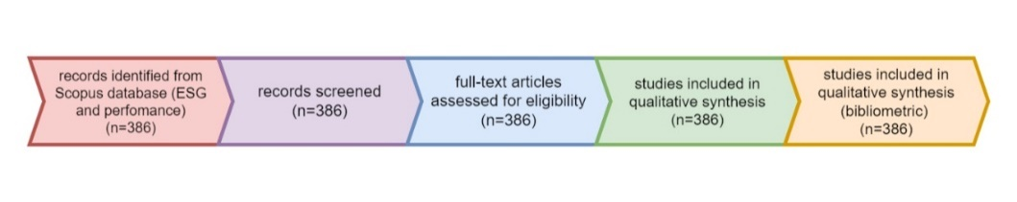
By describing the relevant features were downloaded and stored in an excel file, the bibliographic analysis has been done. The common file related to the meta data such as author name, article title, source keywords, abstract, publishers and other various citation data. This stage that we prepared the data for analysis as a thesaurus file.

  - Visualization Software
Author keywords, article title and citation of 387 documents were exported to Vos-viewer (version 1.6.18). Vos-viewer as a free software can be used to investigates the construct of the journals, authors, data citation, and keywords with visualization diagrams. In this study, the items, specifically the keywords or authors, are the objects of interest. Based on the data displayed by the map-based visualization, the possibility of a connection between things can be observed. The link refers to the relationship or connection between the connected objects. Each relationship between the links implies the presence of a distinct, numerically-positive strength. In the examination of co-authorship, the stronger the connection between the links, the greater the value.

  - Data Analysis
Descriptive analysis as the first assessment in bibliometrics. By using Excel functions, several table and figures were developed with citation metrics. This includes the number of citations, document type, subject area, and keywords. The data from Scopus database was imported into CSV and read to Excel then imported to the Vos-viewer 1.6.18 for co-citation and citation analysis. After that, the converted network file is sent to RIS to perform the PageRank analysis. The results from the conversion divided into some clusters. Each clusters have some content analysis by identifying the idea presented on the articles and the overall from clusters itself.

- Result and Discussion
  - Performance Analysis
By examining the research contributions to the field, performance analysis (e.g., authors, sources and publisher) should have been done for the bibliometric analysis. According to the table 1, there were ten publisher which prominently published an ESG performance research topic. The top highest publisher is MDPI with 69 total publications. This number followed by John Wiley and Sons and Elsevier with the total publications 19, 16 and 11 respectively.

Table 1. The 10 Publishers
 | Journal | Publisher |  | Total publication
1 | Sustainability (Switzerland) | MDPI |  | 69
2 | Business Strategy and the Environment | John Wiley and Sons Ltd |  | 19
3 | Journal of Cleaner Production | Elsevier Ltd |  | 16
4 | Corporate Social Responsibility and Environmental Management | John Wiley and Sons Ltd |  | 11
5 | Frontiers in Environmental Science | Frontiers Media S. A |  | 9
6 | Journal of Sustainable Finance and Investment | Taylor and Francis Ltd |  | 9
7 | Journal of Global Responsibility | Emerald Group Holdings Ltd |  | 7
8 | Journal of Portfolio Management | Portfolio Management Research |  | 7
9 | Journal of Asset Management | Palgrave Macmillan Ltd |  | 6
10 | Frontiers in Psychology | Frontiers Media S. A |  | 5

Furthermore, this study explored the rank of the most productive authors of ESG performance area. The most productive author is Buallay A. With 10 of the total publication in this field and most cited and averaged number of citations were 292 times. Velte has the second author with the citation of 177 times, then followed by Rajesh with 115 citations. However, in the same time, the last two authors, Zhang and Shakil, they have citation with 99 and 13 citations respectively.

Table 2. Top 5 Authors
 | Author | Total publication | Total citation
1 | Buallay, A | 10 | 292
2 | Zhang, D | 4 | 13
3 | Velte | 3 | 170
4 | Shakil, M.H | 3 | 99
5 | Rajesh, R | 3 | 115

The table 3. provided the list of cited publications related to ESG performance from 2017 to 2022. There was various research topic on ESG presented on the papers has been cited by the other authors. The impact of sustainable governance and risk management has 98 citations during the years of publish. Many of the previous studies correlate the ESG into the financial performance of the firms. As we can see from the data, the study of ESG mostly cointegrated with the performance of the firms. Therefore, we can mentioned that, companies with better ESG management will have higher performance (Yu et al., (2018); Crespi & Migliavacca (2020).

Table 3. The Most 10 Title Cited
Rank | Year | Author | Title | Citation
1 | 2018 | Brooks C | The effects of environmental, social and governance disclosures and performance on firm value: A review of the literature in accounting and finance | 214
2 | 2017 | Garcia A. S | Sensitive industries produce better ESG performance: Evidence from emerging markets | 172
3 | 2019 | Xie J | Do environmental, social, and governance activities improve corporate financial performance? | 172
4 | 2019 | Buallay A | Is sustainability reporting (ESG) associated with performance? Evidence from the European banking sector | 145
5 | 2018 | Aouadi A | Do ESG Controversies Matter for Firm Value? Evidence from International Data | 144
6 | 2017 | Velte P | Does ESG performance have an impact on financial performance? Evidence from Germany | 128
7 | 2017 | Mervelskemper L | Enhancing Market Valuation of ESG Performance: Is Integrated Reporting Keeping its Promise? | 111
8 | 2021 | Duque-Grisales E | Environmental, Social and Governance (ESG) Scores and Financial Performance of Multilatinas: Moderating Effects of Geographic International Diversification and Financial Slack | 102
9 | 2018 | Yoon B | Does ESG performance enhance firm value? Evidence from Korea | 98
10 | 2017 | Husted B. W | The impact of sustainability governance, country stakeholder orientation, and country risk on environmental, social, and governance performance | 89

According to the data collection, there was top five publisher which were many articles published, there are MDPI (76 articles), Elsevier (63 articles), Emerald (43 articles), John Wiley and Sons (38 articles), and the last most was Springer science & business media (26 articles). Frontier media, Portfolio management research, Taylor & Francis and Routledge have 16, 13, 12 and 11 articles respectively.

  - Science Mapping
Science mapping analyzes the connections between many components of research, such as co-citations, bibliographic coupling, co-words, and co-authorship. Based on figure 1, a result was displayed as an overlay. The line separating the keywords indicates that both subjects were researched concurrently, and the thickness of the line denotes the frequency and intensity of the association. The association between the two terms is greater when the line is thicker. The size of the tag (circle), on the other hand, reflects the item's weight.
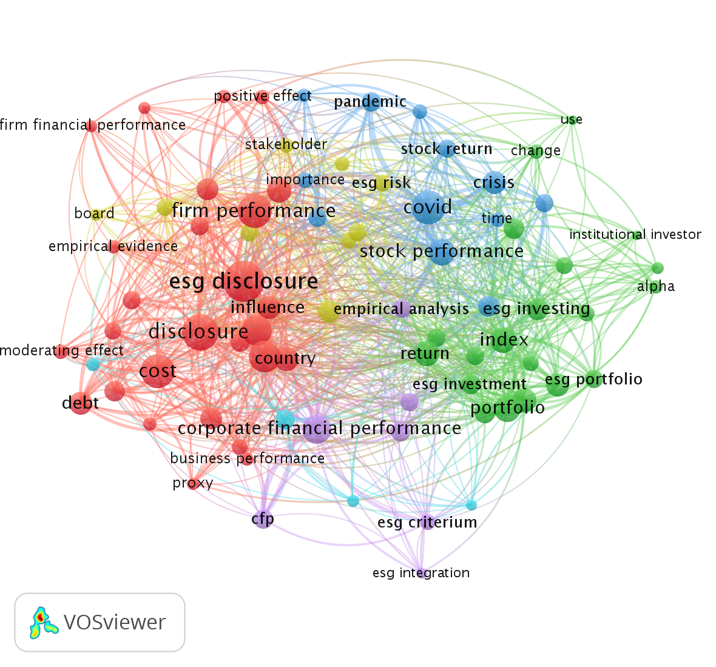
Fig. 1. Network Visualization

  - Enrichment Bibliometric Analysis
Based on the co-occurrence keywords of database, this study shows the primary goal of bibliometric analysis in order to create social cluster of Environmental, social and governance. There was 6 general cluster to summarize the topic of interest in the field of ESG performance.
Cluster 1 as a red cluster keyword, which demonstrates a general interest in investment in global business context, as evidenced with the focused about 47 items keywords such as board diversity, earnings management, environmental disclosure and firm performance. Ahmad et al., (2021) re-examines the impact of ESG performance from 321 firms for the time period 2002-2018, the results revealed that high ESG firms show high financial performance as compared to low ESG firms. However, the return on investment in CSR decreases with the proportion of female directors on the board (Bristy et al., 2021). The study shows how gender plays a role in how firms evaluate and solve the ethical dilemma caused by the connection between corporate social responsibility (CSR) and corporate financial performance (CFP). It also shows how important it is to take gender into account when learning more about how firms deal with the CSR-CFP.
In the second cluster, it can be seen that the correlation between the topic keywords focused on 30 items which was as the green cluster and included the stock performance of the companies, investment performance, responsible investment and sustainable investment. Reber et al. (2021) studied ESG disclosure and performance in order to help corporation to mitigate their risks and investigate the relationship on initial public offerings (IPOs) to build the reputation capital with investors after going public. The other study Lo & Kwan (2017) examined the market responses into the implementation of ESG initiatives. Several implications bring the development of socially responsible investment (SRI) as a corporate strategy. On the other hand, there is no significance difference in the performance between sustainable indices and the traditional conventional indices, being good substitute for the future (Jain et al., 2019).
Cluster 3 presented the topics on corporate sustainability, corporate performance, integrated reporting and framework which are revealed in this cluster (blue cluster). European Union in 2001 proposed the concept of Corporate Social Responsibility (CSR). It refers to a responsibility that companies on their decision making involved the environmental and social factors into considerations. Furthermore, Environmental, Social and Governance have become important pillars of corporate social responsibility. Due to the COVID-19 pandemic, the impact of ESG into the corporate performance has attracted widespread attention. Consequently, Zhou et al. (2022) Utilized financial performance as a moderating variable to examine the relationship between ESG performance, financial performance, and firm market value, as well as their respective mechanisms of influence. The study concluded that an improvement in the ESG performance of publicly traded corporations will increase the market value of the company.
Cluster 4, This cluster (the yellow one) was mostly about governance approach, the ESG dimension, the ESG pillar, and the ESG controversy. As part of ESG, Thomson Reuters also made a score called the controversy score. ESG is made up of three pillars. Institutional investors can look at the social, environmental, and corporate governance effects of the ESG controversy by figuring out which companies are involved in the main ESG controversy, if they follow international norms and principles, and how well they do in relation to these norms and principles. Based on the data presented in the ESG pillar and an overlay of ESGC from international media, the ESGC score provides a detailed evaluation of the company's ESG performance. Additionally, if unfavorable news surfaces in the media, this score enables you to disregard the ESG performance score. The studies by López-Toro et al. (2021) shows there was a direct and positive relationship between the corporate financial performance (through ROA and ROE) and the governance variable.
Regarding to relationship between ESG and bank performance, cluster 5 as the purple cluster was focused on the banking sector, bank performance, equity, asset and the knowledge of an authors. From the perspective of banking, ESG disclosures is vary if measured individually, for example, the environmental disclosure found positively affect the ROA and Tobin’s Q. Whereas, the corporate disclosure found negatively affects the ROA, ROE and positively affects the Tobin’s Q (Buallay, 2018). Furthermore, according to Nizam et al. (2019), there was the positive impact on financial performance in most estimation models controlling for both bank-specific and macroeconomic variables through 75 countries from 2013-2015. However, there was a positive correlation of emerging market bank’s environmental and social performance with their financial performance, meanwhile, the governance performance does not influence financial performance (Shakil et al., 2019).
The main topic on ESG concept, including development, effectiveness model and index, were mentioned in cluster 6 as a blue cluster. ESG ratings and ESG indexes descripted the recent evolutions in the marketplace and profiling by the leading ESG ratings providers such as MSCI, S&P, Dow Jones, FTSE Russell, and Thomson Reuters. And profile a sample of their significant ESG products (e.g., MSCI ACWI ESG Index, Dow Jones Sustainability World Index, FTSE4Good Global Index, and the Thomson Reuters ESG indexes for US Large Cap stocks and developed markets. However, there was a positive correlation between the stated variables, which explained by organizational legitimacy. Therefore, the sustainable and responsible investors are looking for the ESG scores measured by the agencies (Drempetic et al., 2020).
Based on the author data as another type of data selection, it was a chosen button on “create a map base on bibliographic data” then choose read data from reference manager (RIS), type of analysis (co-authorship), unit of analysis (authors) and counting method (full counting) with max number of authors per document is 25 authors. Next step is threshold chosen with minimum number of documents of an author 3, then from 1895 authors, only 73 meet the threshold. This data can be seen from the figure 2.
The second process is mapping for the bibliographic data such as co-authorship, keyword co-occurrence, citation, bibliographic coupling, or co-citation map based on bibliographic data. The next step is data choose source from reference manager files, choosing the type of co-authorship with maximum number of authors per document were 5 authors. The threshold for minimum number of documents of authors is 3, from 1895 authors, there was 73 meet the threshold. The next step, authors choose with 73 authors. Based on figure 4, there was a co-citation network within the authors on the ESG topic. Based on the fractionalize analysis, the density visualization shows that …..

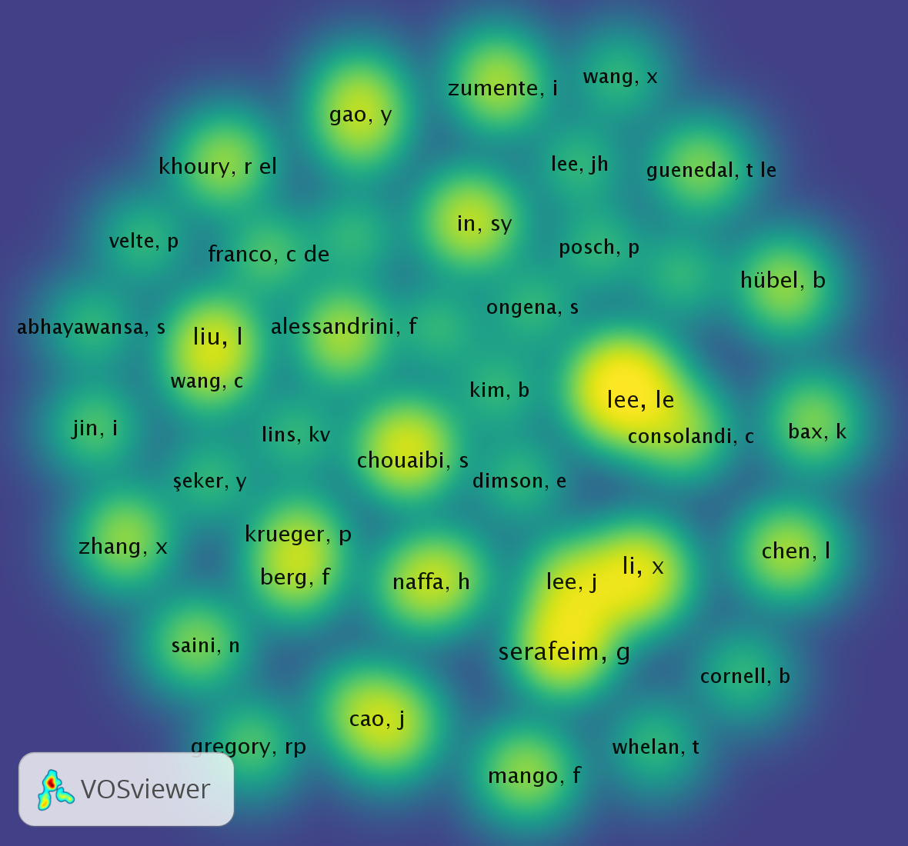
Fig. 2. Visual Representation of The Cited Authors’ Co-Citation Network

  - Keywords Co-occurrence
To determine the future directions of ESG performance research, we studied co-occurrence terms and subject trends. The most refined introduction for an academic essay is its keywords. By observing the co-occurrence of terms in a topic, academics can immediately comprehend the academic field's research hotspots and future research paths. Figure 5 depicts the term co-occurrence graph developed in Vos-viewer for this study. We require a minimum of 10 keyword occurrences for analysis among all 6962 keywords; between 270 keywords match this requirement. Keyword co-occurrence analysis generates a network of subjects and their relationships in a certain field.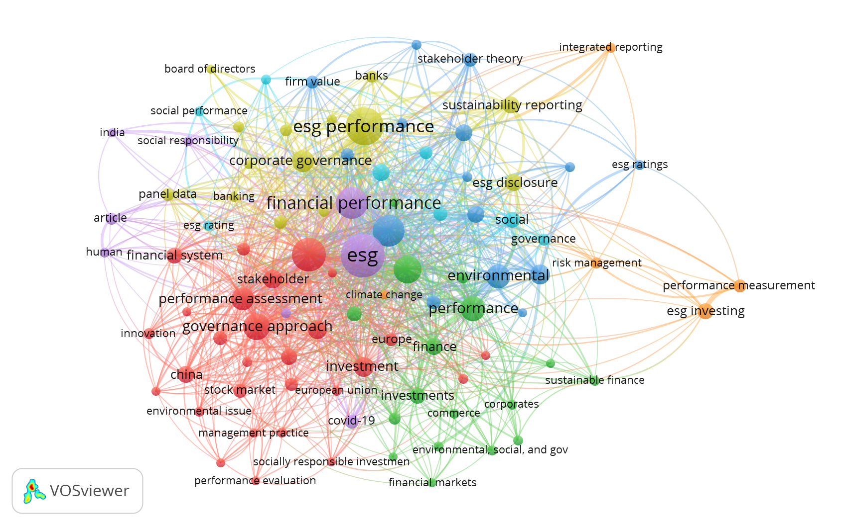
Fig. 3. Co-occurrence Analysis of Author Keywords

  - Empirical Studies on ESG performance
Research on ESG performance has been done through the decades. Most of the empirical studies on ESG performance examined the correlation between ESG and financial performance. A study was conducted by Buallay (2018) examined the impact of ESG and bank’s operational, financial and market performance of 235 banks in European Union countries stock exchange for ten years from 2007 to 2016 from Bloomberg database. This study adopted path analysis to show more advance results to measure whether the data are heavy-tailed or light-tailed relative to a normal distribution. There was ESG has a significant positive impact on the performance. After controlling for bank size, the study shows the positive significant with ROA, ROE and Tobin’s Q model. Whereas, the testing of macroeconomic control variables shows the negatively controls the three models.
Brooks & Oikonomou (2018) examined the literature on environmental, social and governance disclosures and performance and their effects on firm value. The article summarized the main conclusions of 45 years of accounting and financial re-search, including the fact that there is a connection between CSP/ESG and financial performance. The authors also compiled a large body of empirical evidence concerning the direction and intensity of the correlation between ESG disclosures and the performance and financial bottom line of the firm or its marketable financial assets.
According to the study by Amel-Zadeh & Serafeim (2018), in response to the question of why investors use ESG data, most of the respondents (82%) said that they use ESG data because it affects the performance of their investments financially. The biggest problem with using ESG data to make investment decisions is that information from different firms can't be compared. But the research found that motivations, barriers, and how people think returns will affect them are independent variables that can be linked to different ESG investment styles using regressions. The results of this research have an effect on how investments are managed and how ESG data is used.

- Current Topics and Future Research Agenda
Further analysis by using bibliometric is analyzing the trend of keywords of abstract and set the minimum frequency of the keywords for the authors. It can be seen from the figure 4. The common keywords usage in abstract are model, industry, return, cost, board, portfolio, corporate socially responsible, corporate social performance. The frequent occurrence of these keywords among studies reflects more analysis applied to the impact of ESG activity and corporate governance mechanisms (including board of director and employee) on ESG score, and as well as the impact of ESG disclosure on financial performance. The most commonly use into the correlation into ESG score (e.g., bank, portfolio, stock, comparison and SDG’s).

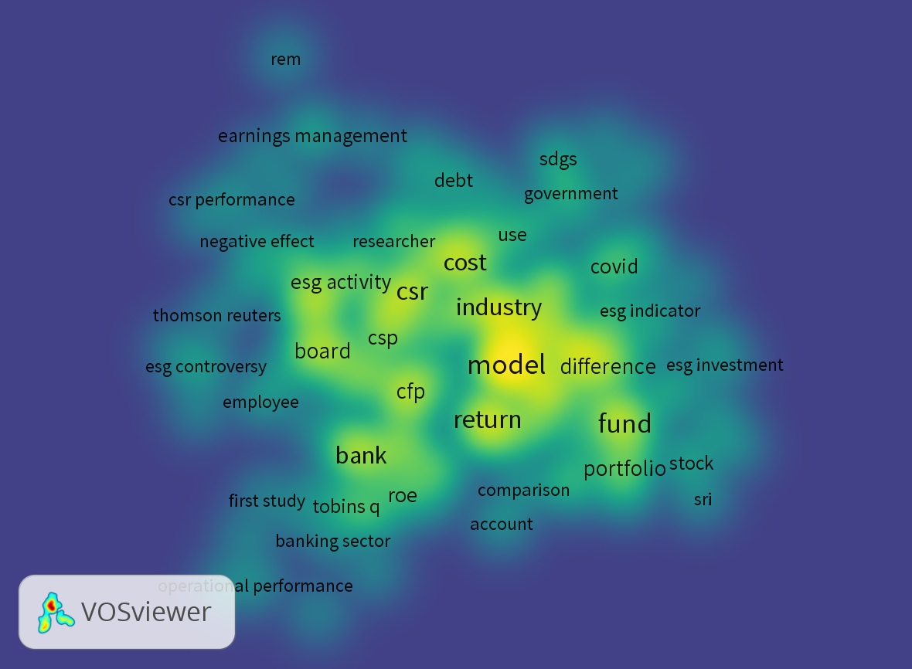
Fig. 4. Co-occurrence Analysis of Author Keywords

- Conclusion and Limitation
The aims of this study to demonstrate a holistic view of ESG performance to determine the knowledge map between the elements from year 2017 to 2022. Bibliometric analyses used in this study to examined the main trends and research trajectories of research field or journals. Due to the breadth of company’s decision impact on the performance, business, investors, stock prices, industry and government. This is evident from the research during the last six years. According to the previous studies of recent research trends and keywords analysis, between environmental and social problems have served as the new factors for the improvement the good corporate governance for the companies worldwide. Therefore, based on this article, many organizations which are needed new insight on ESG factors impact will be helpful as a guidelines for they to come up with the excesses decision making.
Much study needs be undertaken in this sector, as most studies have focused on the impact of ESG disclosure on financial performance, as well as the influence of corporate governance, including the factors influencing the extent of ESG disclosure at the company, industry, and country levels. As a result, society and investors are not just interested in financial performance, but also in corporate environmental and social performance. Companies, however, should not only focus on financial success, but also on contributing to the achievement of development goals at all levels of a company's strategic and financial decisions. This study solely looks at Scopus database documents that have been published. The other database should be used for the ESG disclosure analysis in the future research program. Despite these limitations, this study provided a useful comprehensive summary of prior and current ESG performance literature.

References
Ahmad, N., Mobarek, A., & Roni, N. N. (2021). Revisiting the impact of ESG on financial performance of FTSE350 UK firms: Static and dynamic panel data analysis. Cogent Business and Management, 8(1). https://doi.org/10.1080/23311975.2021.1900500
Ahmi, A. (2021). Bibliometric analysis for beginners. 1–180.
Amel-Zadeh, A., & Serafeim, G. (2018). Why and how investors use ESG information: Evidence from a global survey. Financial Analysts Journal. https://doi.org/10.2469/faj.v74.n3.2
Baas, J., Schotten, M., Plume, A., Côté, G., & Karimi, R. (2020). Scopus as a curated, high-quality bibliometric data source for academic research in quantitative science studies. Quantitative Science Studies, 1(1), 377–386. https://doi.org/10.1162/qss_a_00019
Becker, T. N. (2019). The integrability of ESG investing into robo advising. run.unl.pt. https://run.unl.pt/handle/10362/73601
Brescia, V., Sa’ad, A. A., Hassan, R. B., Alhabshi, S. M. B. S. J., & Lanzalonga, F. (2021). Exploring sustainability from the Islamic finance perspective. European Journal of Islamic Finance, 19(December), 45–53. https://doi.org/10.13135/2421-2172/6107-
Bristy, H. J., How, J., & Verhoeven, P. (2021). Gender diversity: the corporate social responsibility and financial performance nexus. International Journal of Managerial Finance, 17(5), 665–686. https://doi.org/10.1108/IJMF-04-2020-0176
Brogi, M., & Lagasio, V. (2019). Environmental, social, and governance and company profitability: Are financial intermediaries different? Corporate Social Responsibility and Environmental Management, 26(3), 576–587. https://doi.org/10.1002/csr.1704
Brooks, C., & Oikonomou, I. (2018). The effects of environmental, social and governance disclosures and performance on firm value: A review of the literature in accounting and finance. The British Accounting Review. https://www.sciencedirect.com/science/article/pii/S089083891730077X
Buallay, A. (2018). Is sustainability reporting (ESG) associated with performance? Evidence from the European banking sector. Management of Environment Quality, 30(2016), 98–115. https://doi.org/10.1108/MEQ-12-2017-0149
Crespi, F., & Migliavacca, M. (2020). The determinants of ESG rating in the financial industry: the same old story or a different tale? Sustainability. https://www.mdpi.com/2071-1050/12/16/6398
de-Miguel-Molina, B., de-Miguel-Molina, M., Albors-Garrigós, J., Paltrinieri, A., Dreassi, A., Migliavacca, M., Piserà, S., Ferenhof, H. A., Fernandes, R. F., Saygili, E., Arslan, S., Birkan, A. O., Thesis, M., Aarak, S., Werner, H. W., Aboud, A., Diab, A., Economy, F., Cronin, P., … Darmansya, A. (2021). Environmental, Social and Governance (ESG) disclosure, competitive advantage and performance of firms in Malaysia. Sustainability, 13(2), 1–15. https://doi.org/10.1111/acfi.12569
Drempetic, S., Klein, C., & Zwergel, B. (2020). The Influence of Firm Size on the ESG Score: Corporate Sustainability Ratings Under Review. Journal of Business Ethics, 167(2), 333–360. https://doi.org/10.1007/s10551-019-04164-1
Fatemi, A., Glaum, M., & Kaiser, S. (2018). ESG performance and firm value: The moderating role of disclosure. Global Finance Journal. https://www.sciencedirect.com/science/article/pii/S1044028316300680
Friedman, M. (1970). The social responsibility of business is to increase its profits. The New York Times Magazine.
Galletta, S., Mazzù, S., & Naciti, V. (2022). A bibliometric analysis of ESG performance in the banking industry: From the current status to future directions. Research in International Business and Finance, 62. https://doi.org/10.1016/j.ribaf.2022.101684
Handoko, L. H. (2020). Bibliometric analysis and visualization of Islamic economics and finance articles indexed in Scopus by Indonesian authors. In Science Editing. researchgate.net. https://www.researchgate.net/profile/Luqman_Handoko/publication/343772945_Bibliometric_analysis_and_visualization_of_Islamic_economics_and_finance_articles_indexed_in_Scopus_by_Indonesian_authors/links/5f72aa8292851c14bc9cf6fd/Bibliometric-analysis-and-vi
Jain, M., Sharma, G. D., & Srivastava, M. (2019). Can sustainable investment yield better financial returns: A comparative study of ESG indices and MSCI indices. Risks, 7(1). https://doi.org/10.3390/risks7010015
Kim, S., & Li, Z. (2021). Understanding the impact of esg practices in corporate finance. Sustainability (Switzerland), 13(7), 1–15. https://doi.org/10.3390/su13073746
Landi, G; Sciarelli, M. (2018). Towards a more ethical market: the impact of ESG rating on corporate financial performance. Social Responsibility Journal. https://doi.org/10.1108/SRJ-11-2017-0254
Linnenluecke, M. K., Marrone, M., & ... (2020). Conducting systematic literature reviews and bibliometric analyses. Australian Journal of …. https://doi.org/10.1177/0312896219877678
Lo, K. Y., & Kwan, C. L. (2017). The Effect of Environmental, Social, Governance and Sustainability Initiatives on Stock Value – Examining Market Response to Initiatives Undertaken by Listed Companies. Corporate Social Responsibility and Environmental Management, 24(6), 606–619. https://doi.org/10.1002/csr.1431
López-Toro, A., Sánchez-Teba, E. M., Benítez-Márquez, M. D., & Rodríguez-Fernández, M. (2021). Influence of ESGC indicators on financial performance of listed pharmaceutical companies alberto. International Journal of Environmental Research and Public Health, 18(9), 1–20. https://doi.org/10.3390/ijerph18094556
Nizam, E., Ng, A., Dewandaru, G., Nagayev, R., & Nkoba, M. A. (2019). The impact of social and environmental sustainability on financial performance: A global analysis of the banking sector. Journal of Multinational Financial Management, 49, 35–53. https://doi.org/10.1016/j.mulfin.2019.01.002
Pranckutė, R. (2021). Web of science (Wos) and scopus: The titans of bibliographic information in today’s academic world. Publications, 9(1). https://doi.org/10.3390/publications9010012
Reber, B, Gold, A., & Gold, S. (2021). ESG disclosure and idiosyncratic risk in Initial Public Offerings. In Journal of Business Ethics. Springer. https://doi.org/10.1007/s10551-021-04847-8
Reber, Beat, Gold, A., & Gold, S. (2022). ESG Disclosure and Idiosyncratic Risk in Initial Public Offerings. Journal of Business Ethics, 179(3), 867–886. https://doi.org/10.1007/s10551-021-04847-8
Shakil, M. H., Mahmood, N., Tasnia, M., & ... (2019). Do environmental, social and governance performance affect the financial performance of banks? A cross-country study of emerging market banks. In … of Environmental Quality …. emerald.com. https://doi.org/10.1108/MEQ-08-2018-0155
Sheveleva, G. I. (2022). Corporate governance in generating companies of the Russian electric power industry in the context of ESG agenda. Global Energy Interconnection, 5(5), 512–523. https://doi.org/10.1016/j.gloei.2022.10.005
Yu, E. P., Guo, C. Q., & Luu, B. V. (2018). Environmental, social and governance transparency and firm value. Business Strategy and the …. https://doi.org/10.1002/bse.2047
Zhou, G., Liu, L., & Luo, S. (2022). Sustainable development, ESG performance and company market value: Mediating effect of financial performance. Business Strategy and the Environment, March, 1–17. https://doi.org/10.1002/bse.3089

