**LAPORAN HASIL KERJASAMA**

**ANTARA PROGRAM STUDI MANAJEMEN SPs UHAMKA DENGAN SRIPATUM UNIVERSITY OF THAILAND**

**(DalamRangkaStudi Banding &Internasional Seminar)**

**22 – 25 September 2017**

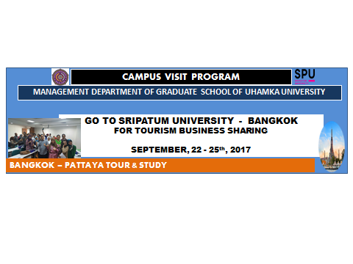

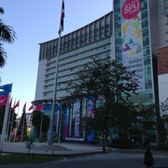

**PROGRAM STUDI MAGISTER MANAJEMEN**

**SEKOLAH PASCASARJANA UHAMKA**

**UNIVERSITAS MUHAMMADIYAH PROF. DR. HAMKA**

**2017**

**KATA PENGANTAR**

*Assalamu’alaikum Warrahmatullahi Wabarakatuh*

Puji syukur penulis panjatkan kepada Allah SWT yang telah melimpahkan rahmat dan hidayah-Nya sehingga penulis dapat menyelesaikan tesis ini. Shalawat dan salam tercurah kepada Baginda Nabi Muhammad SAW yang membawa umat manusia menuju alam pencerahan.

Dalam rangka memenuhi pembelajaran serta wawasan diluar kelas. Sekolah Pascasarjana Universitas Muhammadiyah Prof. Dr. HAMKA acara Studi Banding ke Sripatum University, kerjasama antara prodi manajemen SPS UHAMKA dengan Sripatum University (SPU). Untuk mengemban tanggung jawab membentuk arah dari pembangunan regional, dilakukannya kerjasama antara sekolah pascasarjana UHAMKA dengan Sripatum University of Thailand dengan tujuan meningkatkan pemahaman dan wawasan manajerial dan kepemimpinan diseluruh wilayah Indonesia. Selain itu juga dengan mendukung komunitas melalui program pembinaan masyarakat, serta mengusulkan kebijakan-kebijakan yang mengangkat isu mempersempit kesenjangan antara dunia teori dan praktik di dunia bisnis dan non bisnis.

*Wassalamu’alaikum Warahmatullahi Wabarakaatuh*

Jakarta, 14 Desember 2017

Penulis,

Bambang Dwi Hartono

(Kaprodi Manajemen)

**DAFTAR ISI**

Halaman

**HALAMAN JUDUL**

**KATA PENGANTAR iii**

**DAFTAR ISI v**

**DAFTAR LAMPIRAN xiv**

* 1. PENDAHULUAN 1
  2. Tujuan 3
  3. Rencana Studi Banding Sripatum University 4
  4. Waktu dan tempat 5
  5. Bentuk kegiatan 5
  6. Sumber dana 5
  7. Biaya dan cara pembayaran 5
  8. Susunan panitia studi banding 5
  9. Price realease studi banding SPS UHAMKA 5
  10. Laporan kunjungan peserta studi banding 9
  11. Penutup 11

**LAMPIRAN 12**

* 1. **Pendahuluan**

Sekolah Pascasarjana Universitas Muhammadiyah Prof. DR. Hamka (UHAMKA) merupakan salah satu perguruan tinggi unggulan yang menyiapkan Sumber Daya Manusia Indonesia sebagai generasi muda aset Nasional yang memiliki potensi untuk mengaktualisasikan diri agar dapat berkembang menjadi manusia yang cerdas, berwawasan luas, terampil, menguasai ilmu pengetahuan dan teknologi, beriman dan bertaqwa, serta mempunyai tanggung jawab keilmuan yang tinggi dalam pengabdianya kepada masyarakat, bangsa dan Negara.

UHAMKA juga mengemban tanggung jawab untuk membentuk arah dari pembangunan regional, misalnya dengan meningkatkan pemahaman dan wawasan manajerial dan kepemimpinan di seluruh wilayah Indonesia. Selain itu, juga mendukung komunitas melalui program pembinaan masyarakat, serta mengusulkan kebijakan-kebijakan yang mengangkat isu mempersempit kesenjangan antara dunia teori dan praktik di dunia bisnis atau non-bisnis.

Mahasiswa sebagai insan pelaksana Tri Darma Perguruan Tinggi diharapkan tidak hanya mempelajari teori, namun harus mampu mengaplikasikan langsung dan mengajarkannya kepada komunitas lainnya. Salah satu pengaplikasian secara langsung adalah dengan melakukan kunjungan lapangan. Kita semua sadar bahwa membangun masyarakat yang unggul tidak hanya berdasarkan teori yang didapat, tapi harusdilanjutkan dengan praktik secara langsung ke lapangan. Dengan kunjungan ke lapangan, mahasiswa diharapkan mampu berbagi wawasan dan pengetahuan serta memahami perpaduan antara teori dan aplikasi di lapangan.

Salah satu *Brand* yang harus dibangun oleh Program studi Manajemen adalah seringnya melaksanakan kegiatan pengembangan wawasan ilmiah para mahasiswa yang berskala internasional. Oleh karena itu program studi Manajemen Sekolah Pascasarjana Universitas Muhammadiyah Prof. DR. Hamka Jurusan Manajeman merencanakan kegiatan study Banding untuk berbagi pengetahuan dan sharing tentang manajemen dan kepemimpinan dengan para mahasiswa dan atau civitas akademika lainnya agar memiliki keunggulan bersaing di era pasar bebas ASEAN dan pasar global lainnya.

* 1. **Tujuan**

1. Untuk mengenal dan memahami aspek akademik, khususnya bidang manajemen di Sripatum University yang ada di Bangkok.
2. Untuk mendalami kurikulum yang dipelajari di Sripatum University dengan realita praktik di lapangan khususnya di dunia manajemen.
3. Untuk berbagi wawasan dan pengetahuan tentang manajemen melalui diskusi dan pemaparan dari kedua belah pihak, dan mahasiswa yang hadir mendapatkan sertifikat sebagai peserta.
   1. **Rencana Jadwal Study Banding Sripatum University**

|  |  |  |  |  |  |  |
| --- | --- | --- | --- | --- | --- | --- |
| **Tanggal** | **Hari** | **Dari** | **Ke** | **ETD** | **ETA** | **Itinerary** |
| 22  September  2017 | Jumat | Jakarta | Bangkok |  |  | * Datang ke Bangkok, Bertemu dengan Pemandu Lokal dari travel. * Mengunjungi Pasar Malam Depan Asiatique River * dan Cek di hotel (depan hotel ada pasar malam) |
| 23 September  2017 | Sabtu | Bangkok | Pattaya |  |  | * Sarapan di Hotel, * Kunjungan Universitas Sripatum (Universitas Terkenal Pemerintah Sponsored University Terletak di Bangkok), * Makan Siang di Restoran Al hilal dan Transfer ke Pattaya, * Mengunjungi Galeri Gems (TokoPerhiasan Terbesar di Dunia) * Dinner Buffet di Baan Sukhawadee atau Harbour Restaurant. * Mengunjungi Hard Merchandise Store & Pantai Pattaya * Check in Hotel |
| 24 September  2017 | Minggu | Pattaya | Bangkok |  |  | * Sarapan di Hotel, Tour Nong Nooch Village dengan Makan Siang Prasmanan, * Mengunjungi Honey BeeProduk * Transfer ke Bangkok, En-Route, mengunjungi Pasar Makanan Kering, Kunjungi Toko Kulit Ds, Shopping MBK Mall * Makan Malam Khusus di Restoran Nopparat (Set Thai Menu Dengan DiiringiKesenian Tradisional Khas Thailand) * Mengunjungi Pasar Malam Depan Asiatique River dan check in hotel. |
| 25 September  2017 | Senin | Bangkok | Jakarta |  |  | * Sarapan di hotel, Visit Thai Chocolate House, mengunjungi Wat Arun Temple (Cross Ferry), * Shopping Platinum Fashion Mall * Transfer ke Bandara |

* 1. **Waktu dan Tempat**

Kegiatan ini insyaAllah akan dilaksanakan pada:

Tanggal : 22 s.d 25 September 2017

Tempat : Universitas Sripatum, Bangkok

* 1. **Bentuk Kegiatan**

Kegiatan ini berupa kunjungan studi banding mahasiswa dan membangunsarana pertukaran informasi dan pengetahuan melalui diskusi dan pemaparan makalah kedua belah pihak (dari Prodi MM dan Sripatum University).

* 1. **Sumber Dana**

1. Iuran Mahasiswa, dan
2. Pascasarjana
   1. **Biaya dan cara pembayaran**
3. Per-orang @Rp. 5.500.000,00
4. Cicilan perbulan Rp. 465.000.00 selama 12 bulan
   1. **Susunan Panitia Studi Banding**

Penanggungjawab : Prof. Dr. H. Abd. Rahman A. Ghani. M.Pd.

Dosen Pembimbing : Dr. Bambang Dwi Hartono, M.Si.

Dr. Ir. Sintha Wahjusaputri,MM

Ketua Pelaksana : Dwi Purwandi

Sekretaris : Anggia Arifiati R

Bendahara : Purwatiningsih, Sri Mulyani

Acara : Emi Fitriyani

: Supatmi Sutrisno Darmoprawita

* 1. ***Price realese study* banding Sekolah Pascasarjana UHAMKA, Senin 25 September 2017**

Senin pagi, 25 September 2017, Mahasiswa program Studi Manajemen, Manajemen Administrasi Pendidikan dan Pendidikan Bahasa Indonesia, Sekolah Pascasarjana Prof. Dr. HAMKA, Jakarta, tiba di Universitas Sripatum, Bangkok Thailand, dalam kegiatan Study Banding yang berjumlah 53 peserta. Kamidisambut dengan sangat ramah oleh Tuan rumah, yakni para Dosen dan mahasiswa Sripatum University

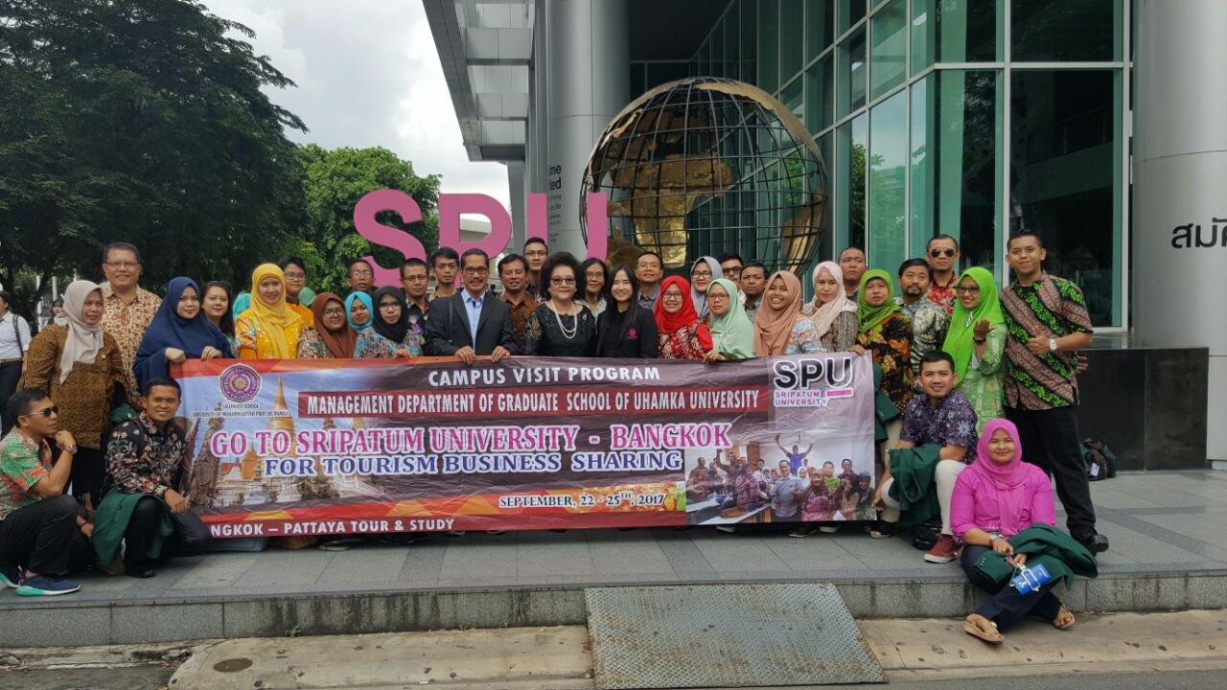

Adapun rangkaian kegiatan study banding yang dilaksanakan mulai pukul 8.30 sampai 11.00 ini diantaranya yakni:

1. *“Overview of Sripatum University”*atau tour kampus untuk mengenal Sripatum University. Ditayangkan secara digital dalam bentuk DVD *Presentation*, mengenai Sejarah, profil, dan sistem pendidikan di Sripatum University.
2. “*Welcome Address & Introducing Faculty Members*”, yakni perkenalan pimpinan fakultas dari Universitas Sripatum. diantarnya:
3. Mrs. Chinda Tejavanija Chang, Wakil pimpinan dari Bidang Internasional, Perguruan tinggi pariwisata dan Perhotelan.
4. Dr. Monticha Khruasuwan, Dekan Perguruan tinggi Pariwisata dan Perhotelan
5. Ms. Ranee Amarinrut, Asisten Dekan Bidang akademik.
6. Ms. Sala Yammiklin, Asisten Dekan Bidang kemahasiswaan.
7. Mr. Thanakorn Narongvanich, Kepala bisnis Airline.
8. Ms. Surssavadee Chakshuraksha, instruktur bisnis airline.
9. Dr. Panot Asawachai Ketua Program studi Manajemen Pariwisata..
10. Ms. Tuaenjai Srichada, Ketua Program Studi Manajemen Perhotelan.
11. Mrs. Nitana Maluangnon Industry, Manajer perhubungan, perguruan tinggi pariwisata dan perhotelan.

Dan perkenalan pimpinan dari sekolah pascasarjana UHAMKA, Yakni:

1. Dr. Bambang Dwi Hartono, M.Si, Ketua Program Studi Manajemen, Sekolah Pascasarjana UHAMKA.
2. Dr. Budi Permana Yusuf, SE, MM,  Kepala Quality Control Program Studi Manajemen.
3. Dr. Ir. Shinta Wahjusaputri, Dosen Manajemen strategik, Program studi manajemen
4. Dr. H. Moh. Suryadi Syarif, SE., MM.Dosen Manajemen Pemasaran, Program Studi Manajemen.
5. Oktarina Heriyani, S.Si, MT, Dosen Fakultas Ekonomi dan Bisnis.
6. Eti Rochaeti, SE., MM. Dosen Fakultas Teknologi.
7. Berikutnya ialah acara inti, diskusi tentang *start-up* bisnis, aBisnis Perhotelan dan Pariwisata. Yang disampaikan oleh Dr. H. Bambang Dwi Hartono, sebagai pembicara dari Sekolah Pascasarjana UHAMKA dan Dr. Monticha Khruasuwan, sebagai pembicara dari Sripatum University

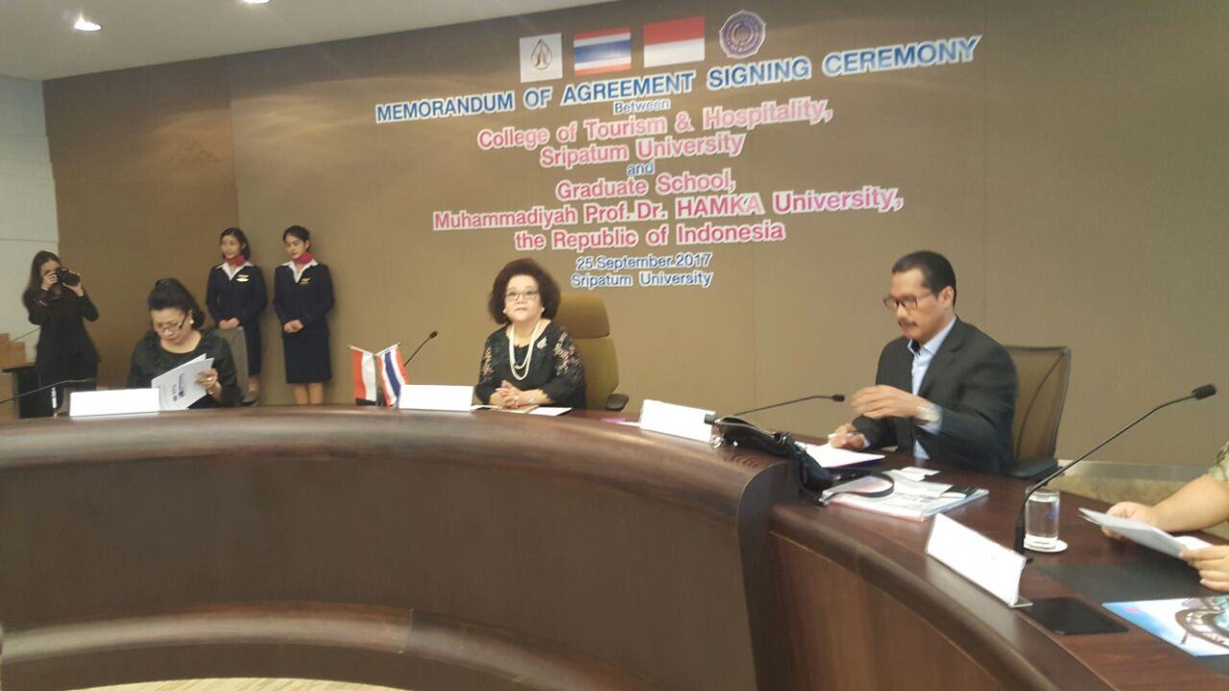

1. Kemudian penandatanganan dan penyerahan MoU antara Sripatum University dan Sekolah Pascasarjana UHAMKA tentang:
2. Pengembangan program yang dirancang untuk mempromosikan kerja sama yang tidak terbatas pada bidang pendidikan dan pelatihan bagi siswa dan staf.
3. Pengembangan proyek dan program di bidang tertentu yang menjadi kepentingan bersama.
4. Pengembangan kursus yang diberikan secara resmi dan kursus pengembangan profesional yang disepakati bersama oleh kedua institusi.
5. Pengembangan proyek penelitian kolaboratif, program pertukaran fakultas dan mahasiswa dan kolaborasi di bidang seminar dan konferensi.
6. Pengembangan gelar *dual degree* atau gelar bersama untuk program akademik yang disepakati bersama.
7. Tepat pada pukul 11.00 acara ini ditutup oleh pemandu acara. Sebelum acara penutupan, ada acara penyerahan cinderamata yang diberikan oleh Ketua Prodi Manajemen Sekolah Pascasarjana UHAMKA kepada Dekan Fakultas Pariwisata dan Perhotelan Universitas Sripatum dan sebaliknya.

Setelah acara ditutup kemudian dilanjutkan sesi foto bersama di auditorium pertemuan kampus Sripatum University. Syukur alhmadulillah, berkat dukungan dan kekompakan dari Dosen dan Peserta acara study banding ini berjalan dengan lancar dan sukses, serta dapat menjalin kerjasama dan kekeluargaan dengan Sripatum University, dan tentunya sangat memperkaya wawasan ilmu pengetahuan dan pengalaman.

* 1. 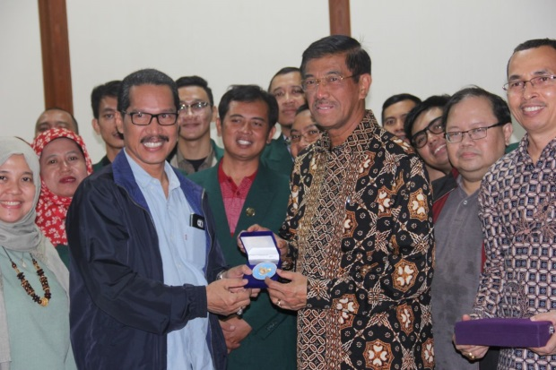 **Laporan kunjungan peserta studi banding ke KEDUBES RI Bangkok Thailand**

1. Penyerahan cindera mata kepada Bapak Kedutaan Besar Republik Indonesia Bangkok setelah acara diskusi.

1. Acara diskusi dengan Prof. Mustari, M.Pd selaku Atase Pendidikan di Bangkok.

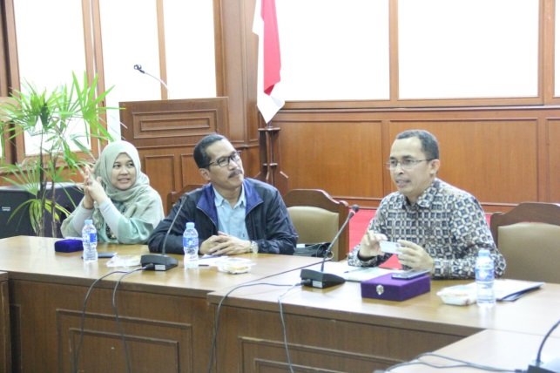

1. AnggiaArifiati Reksodiputro, mahasiswa Program Studi Manajemen yang aktif bertanya pada saat diskusi.

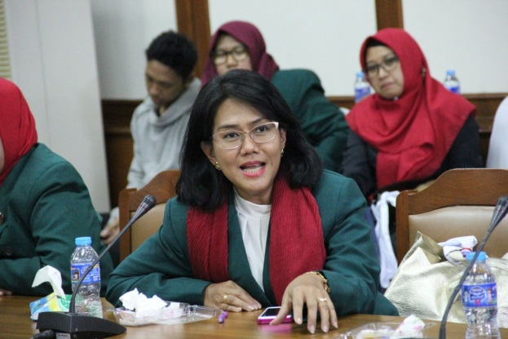

1. Foto bersama bapak Atase Pendidikan sebelum meninggalkan KBRI Bangkok.

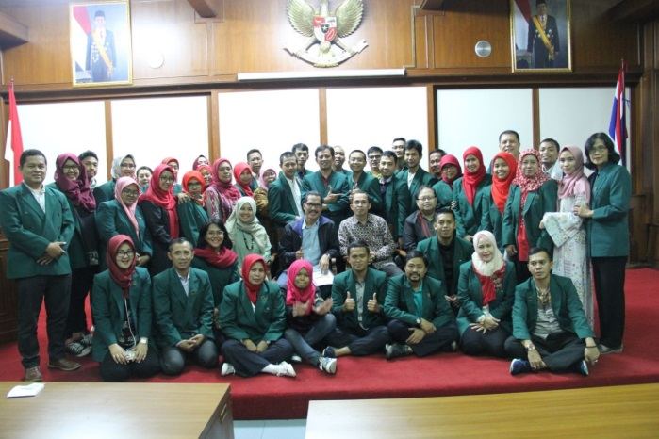

1. Dosen pendamping foto bersama Prof. Mustari, M.Pd.

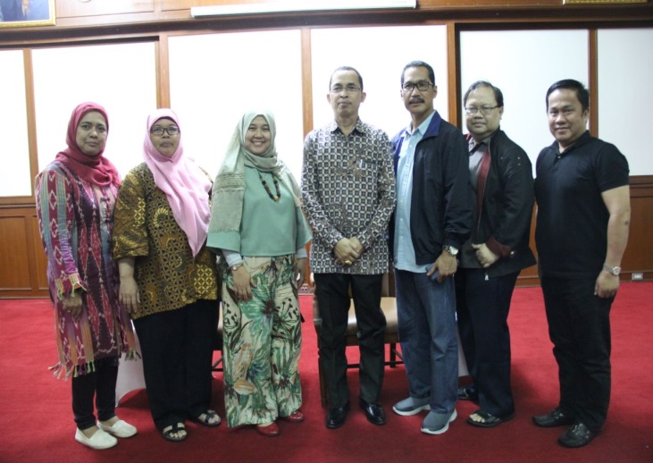

* 1. **. Penandatanganan SPK dan Kolaborasi Seminar di Sri Patum University**

Sesuai dengan maksud dn tujuan dari kerjasama antara Progrm Studi Manajemen Sekolah Pasca sarjana UHAMKA dengan Sripatum University yaitu di bidang Riset, kolaborasi Seminar dan pertukaran mahasiswa, maka pada kegitan awal ini yaitu di kampus Sripatum University pada bulan september 2017 telah dilakukan penandatanganan SPK dan sekaligus pelaksanaan kolaborasi seminar dimana Nara sumbernya berasal dari kedua belah pihak. Adapun dibawah ini adalah foto saat dilakukan penandatangan SPK:

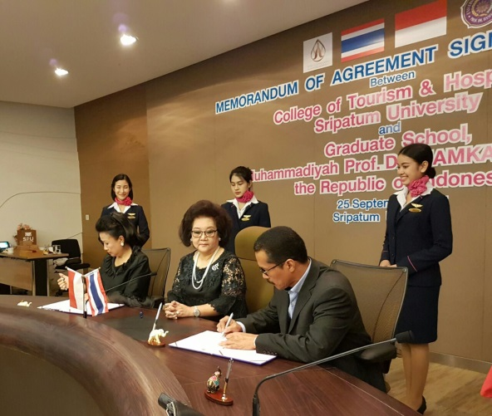

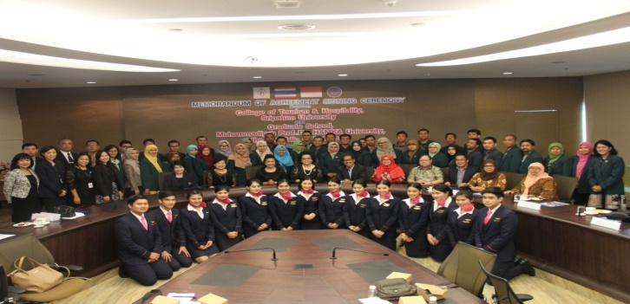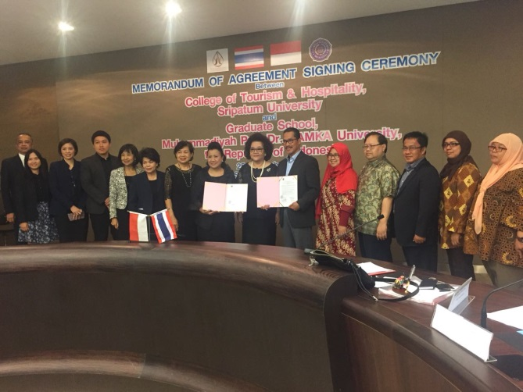**. Materi seminar dan presentasi dari Prodi Manajemen UHAMKA**

Sebagai wujud kerjasama, maka dilaksanakan kegaiatan seminar yang nara sumbernya berasal dari kedua belah pihak. Adapun topic atau tema seminar telah disepakati tentang “**The Development on Start-up Business in Indonesia and  Tourism Business in Thailand”.** Dari pihakUhamka yang menjadi Nara sumber adalah Dr. H. Bambang Dwi Hartono, MSi dan dari Pihak Sripatum University adalah Dekan Fakultas Pariwisata dan Perhotelan Universitas Sripatum.

* 1. **. Materi Prsentasi Dr. Bambang Dwi Hartono**

**TO AVOID STARTUP BUSINESS FAILURE**

**THROUGH ENTREPRENEURSHIP, CUSTOMER DEVELOPMENT,**

**AND DESIGN THINKING APPROACH**

**By Dr.H. Bambang Dwi Hartono, Msi**

Head of Management Department of UHAMKA Graduate School

1. **Background of Study**

This study is based on the phenomenon which is that many entrepreneurs, either new or existing, of either small, medium, or large-sized level, experience business failure. Many new entrepreneurs slowly realize that their business is wasting money and leads to bankruptcy.

Ministry of Communication and Informatics of Republic of Indonesia has launched a program called *Gerakan Nasional 1.000 Startup Digital*. The program launced on 17 June 2016 is expected to result in 1,000 startup businesses in Indonesia in 2020.

Since its launching, there are 16,500 registered participants who are from six cities in Indonesia. In the first stage were 2,267 participants selected to continue to the next stage. After assessment on ideas and formulated problems to solve, only 41 participants were successfully chosen as prospective startup business. It indicates that most of startup businesses have not been able to both formulate creative and innovative ideas and find required business solutions.

The objective of this study is to explain how a startup business does not fail while operating. Besides, it is also aimed to explain the importance of entrepreneurship approach, customer development approach, and design thinking approach for providing a guideline, skills, and effective belief to particularly new entrepreneurs to make their business successful.

**Phenomenon of startup business development**

Visiting Silicon Valley, the United States of America, on behalf of the government of Indonesia, Ministry of Communication and Informatics launched a program, “*Gerakan Nasional 1.000 Startup Digital*” which is expected to result in 1,000 startup businesses in Indonesia in 2020.

Through this program it is projected that economical value of the 1,000 startup business can reach US$ 10 billionthat is equal to 130 zillion rupiahs. The projection is not overstating since it is considered that a successful new startup business has a considerable high value as shown in Figure 1.

There is a business classified into type C, known as “Startup” that has been able to give big values to consumers although it just operated for two to three years. For example, Instagram which has only a dozen of employees and is able to serve hundreds of users throughout the world is finally bought by Facebook for $ 1 billion. Compared to a business of type A, a business which has been operated for years, Instagram has higher value.

Differently, both “FoodPanda” and “YESBOSS which are startup business closed their business in Indonesia since they cannot compete with “Gojek” which has “Go Food” product.

In accordance with the background of the study, it is concluded that a startup of business which is able to produce business solution will keep successful, whereas the business hich is not able to create brilliant ideas and formulate business solution needed by consumers will fail. Therefore, effective entrepreneurial skills and customer development approach are required to both examine and validate products or services to offer to consumers.

1. **Startup**

Eric Ries, the writer of The Lean Startup, stated, “A startup is a human institution designed to deliver a new product or service under conditions of extreme uncertainty. Startups are designed for the situations that cannot be modeled, are not clear-cut, and where the risk is not necessarily large - it's just not yet know”.

According to Steve Blank (2012), startup is an organization formed to search for a repeatable and scalable business model.

Another definition of startup is proposed by Paul Graham, a founder of one of the best startup accelerators in the world. He stated, “A startup is a company designed to grow fast. Being newly founded does not in itself make a company a startup. Nor is it necessary for a startup to work on technology, or take venture funding, or have some sort of "exit." The only essential thing is growth. Everything else we associate with startups follows from growth”

Based on those definitions, it is said that start up is a new business which is designed for fast growing.

1. **Concept of Entrepreneurship, Customer Discovery and Design Thinking**
2. **Creativity andEntrepreneurship**

Creativity is an attitude that leads to innovation, new method, and key formula for successful entrepreneurship. Nowadays, entrepreneurs is facing a future which is always under certainty. It is a fact that in even the worst environment creative people are able to solve problems to catch any opportunities, to adapt to the environment, and to utilize it in innovative ways.

Innovation is how a company or person generates money from creativity (Higgins: 1994). The process of producing new things is known as origination. Something which is original refers to that is new and previously not available. The creativity is defined as the process of creating new and valuable things. There are many ideas and concepts which are not original, but some of them are not valuable so that they cannot be considered creative. Thus, a creation refers to original and valuable thing.

Moreover, innovation is defined as a process of creating new things which give values to a person, a group of people, an organization, and society. Therefore, an innovation is a creation which has high value. Creative people are those who have high curiosity and compassion toward their surroundings. They are open to receive any ideas by perceiving that the ideas are useful for their early consideration. Creative people also have high tolerance toward plurality.

The formulation of entrepreneurship concept can be found in some literature such as Dolingger (1999) stating that it is universally characterized by an order of individual values involving skills to utilize opportunity and to take risk, enabling basic managerial skills, and drive for creativity, innovation and further vision creation. An entrepreneur is actually a person who can be a pioneer in developing ideas into products and realizing dreams and always sees opportunity for creation and new ideas execution (Alen, 1999)

**Emergence of Innovation and Creativity**

In addition to brilliant ideas and dreams, creativity is an essential package for successful leader both in private sectors and public sectors. More importantly, for an entrepreneur, creativity is a resource which is more difficult to immitate than physical resources such as money.

Competitiveness ability of a company or organization is influenced by the existence of continuous innovation which is always produced by human resources, either individual or group.

Nonaka and Takeuchi (1995) proposed that knowledge has three definitions which are (1) beliefs dan commitment, (2) action dan (3) meaning. The success or failure of an organization depends on the leader’s beliefin the subordinates and the subordinates’ beliefin the leader in managing the organization. If they have the same belief in developing the organization, the next stage is how they do their actions and finally give meanings to the achieved development.

Furthermore, Nonaka and Takeuchi (1995) classified knowledge into two categories which are tacit knowledge and explicit knowledge. Tacit knowledge is the result of personal experiences, and it is valid here and now and is practical. While explicit knowledge is based on mind, is valid anywhere and everywhere, and is digital knowledge. The combination of those knowledge leads to the emergence of creativity and innovation.

**Strategy of Creativity and Innovation Development**

In creativity development, there are three influencing components, which are (1) expertise, (2) creative thinking skills, and (3) motivation (Waring, 1996). Entrepreneurship in developing business is highly dependent on the types of business and accompanying characteristics which involve: (1) Administrative Entrepreneur, (2) Performer, (3) Integrator, dan (4) Entrepreneur.

To have an organization able to create knowledge, all individuals in the organization must be bale to change their mindset. Covey (1993) proposing the way to change mindset through implementation of individual habits, known as The Seven Habits of Highly Effective People; the habits involve: (1) be proactive, (2) begin with the end in mind, (3) put first things first, (4) think win-win, (5) seek first to understand, then to be understood, (6) synergize, sharpen the saw

Individual learning model (Figure) can be a strategic model for emerging individuals with high competence to be great entrepreneurs who can create creativity and innovation continuously.

**Implement**

**Observe**

# **Design**

**Assess**

**Individual Learning**

The model explains how an individual can have skills to develop creativity and innovation through the following stages: (Kofman, 1993) and (kim, 1993) (1) consistent observation on the environment which is relevant to business, (2) serious assessment based on the observation result to find out prioritized solutions, (3) implementation of solution options in the form of design, and (4) trial of the solution options for either positive or negative responses. The stages are repeated consistently so that the business can be adjusted to the behavior and interest of consumers.

1. **Customer Development**

To learn from field and to find mistakes in a precise and efficient way is through customer development approach. Steve Blank and Bob Dorf, in The Startup Owner’s Manual (2012), explained some advantages of customer development, involving:

1. to seek a precise business model before the execution
2. to provide framework and stages which enable new entrepreneurs to start their business immediately with minimum capital and to find the precise business model based on learning from mistakes
3. Not to either extend the chain of planning or complicate the execution, but to accelerate the creation of startup business without big capital due to some mistakes

In brief, it is concluded that customer development is a systematic framework for: (1) finding and validating product markets, (2) developing precise features of product to meet the customer needs, (3) testing the right method for discovering customers, and (4) utilizing the right resources to increase the business scale.

Model of customer development includes four stages which are: (1) customer discovery, (2) customer validation, (3)customer creation, and (4) company building.

**Customer discovery**

Founders of business will do research on costomer needs of a product. Knowing the needs of customers, they translate the needs to hypothesis of business model, and they create an initial product.

**Customer validation**

The hypothesis are tested and customer interest is validated through initial order or product use. If there is not any interest of customer discovered, the startup process is repeated.

**Customer creation**

Market system of the products which are worth selling and successfully selected in the two previous stages will be developed, and the existing business scale will be increased.

**Company building**

Following the three stages, transition of startup model to bigger model with function of departments is performed.

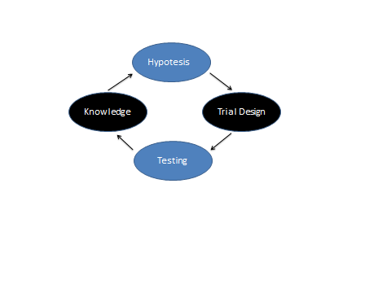The four stages are a strategy of developing startup business. Before creating and developing a startup business, itis important to understand customers. To discover customer is also done before finding fund, marketing etc. entrepreneurs must know whether or not their products will attract customers. If the products are not accepted in market, to change into better business ideas or pivot is suggested.

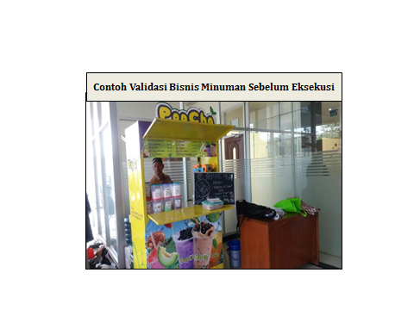Implementing customer development approach, a startup business can grow faster because the launched products and services are considered valid based on the cycle as shown in the figure. The cycle includes: (1) hypothesis of product or service validity, (2) trial design, (3) filed testing, and (4) knowledge creation from testing result for startup managers to execute and develop the business or to change the strategy.

Referring to personal experience, for example, PopCa, a business of fresh drink that uses basic material form CNI, is shown in figure. Firstly, people like the product due to the various flavoured and bubble topping offered. A test was conducted to check if the product is truly favorite of customers and if it is affordable. The result shows that most of people like PopCa. Because the test location is a campus with 6,000 students, the business can sell about 100 cups per day.

The belief to decide if the business mentioned is avlid or not was based on the test of hypothesis through the following steps:

1. to go outside the building for experiencing business failure and ensuring the customer needs
2. to be willing to test hypothesis in front of customers
3. to design experiments carefully
4. to get signal for the next process based on the first test, not to be precised
5. to have required knowledge to develop
6. to know the initial simple test which can be done
7. to know how to design an experiment for executing the simple test

Another personal experience shows a business of coffee shop, namely “leaora Coffee” will never develop if it does not implement customer development strategy. When the number of customer decreases, design thinking is necessary to create new innovation, which is in accordance with the consumer needs, for both productand marketing strategy. In this case, the design thinking involves:

1. Required facilities for a café such as sport equipment like tennis table and bilyard. The equipment offers amusement to customers.
2. Coffee products which become favourites such as iced coffee. Innovation is necessary to make ice cube from coffee so that the taste of coffee remains good.

There are many failed startup businesses, either of products or services. The failure happens since the entrepreneurs do not test if their products or services are truly valid or not. For example, Aqua flash, alhami, salami mie gaga, Mie ABC etc. It is only Mie Sedp which is able to stay comptetive with Indofood products. Other examples of business failure are FoodPanda and YessBoss; they are not valid.

Another essential approach to avoid startup business failure is design thinking.

1. **Design Thinking**

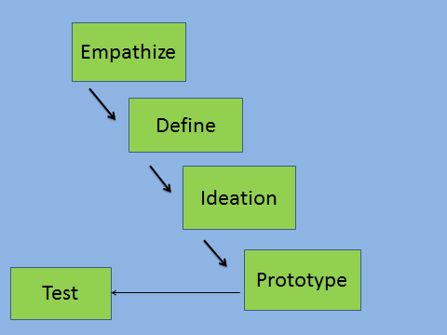

According to Hendry Ramdhan, a writer of *Menjadi Entrepreneur Startup* 2016, design thinking is a process to generate innovation by focusing on individual, and the result is product or service that rightly becomes solutions needed by society. Therefore, design thinking approach is appropriate for those who need brilliant ideas for developing startup business. Figure 3 represents the stages of design thinking strategy before creating startup business

Based on the figure, the first stage of design thinking is to emphatize, that is understanding the needs of target market. Through this stage an entrepreneur can create a product which is rightly needed by many people. The second stage is to discover point of view. It is followed by creating prototype or model based on the business ideas. The last stage is to test the product to know the response of customers for improvement.

Through the implementation of design thinking approach, “Airbnb” company which is a startup company providing rooms for rent throughout the world was stagnant in 2009; then it increased to $ 400 per week. This occurs because the company was willing to plunge into the real world to find problems and solutions. This is the point of design thinking. The successful implementation of the approach results in successful startup business. For example is redesigning experience of the use of sport equipment for professional athletes, experience of taxi order for professional executives, and experience of taking ojek.

Based on the explanation above, it is concluded that running a business or startup business will lead to continuous lost because of waste of money; this happens because the created products or services are not valid and are not business solutions needed by consumers. Therefore, it suggested that new entrepreneurs who will start their business: (1) study the concept and practice of entrepreneurial values in the real world, (2) implement customer development approach and its stages and practice the cycle to test the validity of their products and services, and (3) implement design thinking model to find business solutions which are rightly needed and test the responses of prospective customers.

Conclusion:

1. A business without continuous creatitivy and innovation will experience failure since it is not in line with the change of consumer behavior; approach of entrepreneurial values is required.
2. A business which is designed inside the building without any view of problems in the real world outside will waste money and experience failure because the right business solutions are not found. To avoid the failure, customer development is needed.
3. A business which is operated without emphaty process as its initial stage in creating business ideas will fail.

# DaftarPustaka

1. Adam,E. and E. Chell. 1993. The Succesful International Entrepreneur: A Profile.

Paper presented to the 23rd European Small Business Seminar. Belfast

1. Allen, KR. 1999. Launching New Ventures an Entrepreneurial Approach.

Houghton Mifleen. Co

1. Bird, B. 1995. Toward a Theory of Entrepreneurial Competency. Advances in

Entrepreneurship, Firm Emergence and Growth 2 : 51 – 72

1. Covey, S.R. 1993. The Seven Habits of Higbly Effective People. Simon &

Schuster Inc.

1. Dollinger M.C 1999. Entrepreneurship : Strategies and Resources. Prentice Hall,

Upper Saddle River, New Jersey

1. Eric Ries **,** The lean Startup : How Today’s Entrepreneurs use continuous innovation to create Radically Successful Businesses, 2011
2. Hendry Ramdhan, Menjadi Entrepreneur Startup, 2016
3. Kofman, F. & Senge, P.M. (1993). Communities of commitment: The heart of learning organizations. ***Organizational Dynamics***, 22, 5-23.
4. Kim, D. H. (1993) ‘The Link Between Individual and Organisational Learning’ , Sloan Management Review (Fall): 37-50 .
5. Nonaka, I. and Ha. Takeuchi 1995 The knowledge Creating Company, Oxford

University Press

1. Senge, PM. 1990 , The Fifth Discipline The art and Practise of Learning Organization. Century. London 1990
2. Steve Blank and Bob Dorf, The Startup Owner’s Manual, 2012
3. Steven G. Blank , “The Four Steps to the Epiphany”, Printed by Lulu.com , Published 2006
4. Waring, A. 1996 Practical System Thinking Int. Thomson Business Press

Demikianlah laporan ini kami susun sebagai suatu bentuk kegiatan untuk bertukar informasi dan mempererat tali silaturrahmi. Dukungan dan partisipasi dari semua pihak sangat kami harapkan demi kelancaran dan kesuskesan kegiatan ini.

Semoga kegiatan ini dapat berjalan lancar dan sukses. Atas perhatian dan partisipasi dari semua pihak sangat kami harapkan demi kelancaran dan kesuksesan kegiatan ini.

**Lampiran 1. PRESENSI PESERTA**

**KEGIATAN STUDY BANDING BANGKIK THAILAND**

|  |  |  |  |  |  |  |  |  |  |  |  |  |  |  |  |  |  |
| --- | --- | --- | --- | --- | --- | --- | --- | --- | --- | --- | --- | --- | --- | --- | --- | --- | --- |
| **NO** | **NAMA** | **HARI** | | | | | | | | | | | | | | | |
| **JUMAT** | | | | **SABTU** | | | | **MINGGU** | | | | **SENIN** | | | |
| **1** | **2** | **3** | **4** | **1** | **2** | **3** | **4** | **1** | **2** | **3** | **4** | **1** | **2** | **3** | **4** | |
| 1 | Dr. H. Bambang Dwi Hartono, M.Si |  |  |  |  |  |  |  |  |  |  |  |  |  |  |  |  | |
| 2 | Dr. Ir. Sintha Wahjusaputri, MM |  |  |  |  |  |  |  |  |  |  |  |  |  |  |  |  | |
| 3 | Dr. Budi Permana Jusuf, SE., MM. |  |  |  |  |  |  |  |  |  |  |  |  |  |  |  |  | |
| 4 | Prof. Dr. H. Abdul Madjid Latief,MM |  |  |  |  |  |  |  |  |  |  |  |  |  |  |  |  | |
| 5 | Dr. H. Moh. Suryadi Syarif, SE., MM. |  |  |  |  |  |  |  |  |  |  |  |  |  |  |  |  | |
| 6 | Oktarina Heriyani, S.Si, |  |  |  |  |  |  |  |  |  |  |  |  |  |  |  |  | |
| 7 | Eti Rochaeti, SE., MM |  |  |  |  |  |  |  |  |  |  |  |  |  |  |  |  | |
| 8 | Muchammad Tri Prabowo |  |  |  |  |  |  |  |  |  |  |  |  |  |  |  |  | |
| 9 | Tashia Indah Natiti |  |  |  |  |  |  |  |  |  |  |  |  |  |  |  |  | |
| 10 | Ni Wayan Dewi Susanti |  |  |  |  |  |  |  |  |  |  |  |  |  |  |  |  | |
| 11 | Tatik Nurhalisah |  |  |  |  |  |  |  |  |  |  |  |  |  |  |  |  | |
| 12 | Supatmi Sutrisno Darmoprawita |  |  |  |  |  |  |  |  |  |  |  |  |  |  |  |  | |
| 13 | Purwatiningsih |  |  |  |  |  |  |  |  |  |  |  |  |  |  |  |  | |
| 14 | Muhammad Arief |  |  |  |  |  |  |  |  |  |  |  |  |  |  |  |  | |
| 15 | Suliyanti |  |  |  |  |  |  |  |  |  |  |  |  |  |  |  |  | |
| 16 | Yuni Setiani |  |  |  |  |  |  |  |  |  |  |  |  |  |  |  |  | |
| 17 | Dwi Purwandi |  |  |  |  |  |  |  |  |  |  |  |  |  |  |  |  | |
| 18 | Eko Kardiyanto |  |  |  |  |  |  |  |  |  |  |  |  |  |  |  |  | |
| 19 | Hendra Setia Suprihatin |  |  |  |  |  |  |  |  |  |  |  |  |  |  |  |  | |
| 20 | Sutaryo |  |  |  |  |  |  |  |  |  |  |  |  |  |  |  |  | |
| 21 | Yudhi Purnawan |  |  |  |  |  |  |  |  |  |  |  |  |  |  |  |  | |
| 2 | Darhayeni |  |  |  |  |  |  |  |  |  |  |  |  |  |  |  |  | |
| 23 | Ari Nugroho |  |  |  |  |  |  |  |  |  |  |  |  |  |  |  |  | |
| 24 | Anggia Arifiati Reksodiputro |  |  |  |  |  |  |  |  |  |  |  |  |  |  |  |  | |
| 25 | Sri Mulyani Slamet Riyadi |  |  |  |  |  |  |  |  |  |  |  |  |  |  |  |  | |
| 26 | Taufik Hadi |  |  |  |  |  |  |  |  |  |  |  |  |  |  |  |  | |
| 27 | Fadiah Dini Hanifa |  |  |  |  |  |  |  |  |  |  |  |  |  |  |  |  | |
| 28 | Ryan Dinarta Kusuma |  |  |  |  |  |  |  |  |  |  |  |  |  |  |  |  | |
| 29 | Emy Fitriyani |  |  |  |  |  |  |  |  |  |  |  |  |  |  |  |  | |
| 30 | Khaderi |  |  |  |  |  |  |  |  |  |  |  |  |  |  |  |  | |
| 31 | Zaki Fuadi Dhiauddin |  |  |  |  |  |  |  |  |  |  |  |  |  |  |  |  | |
| 32 | Muhammad Rafi Tauchid Nugroho |  |  |  |  |  |  |  |  |  |  |  |  |  |  |  |  | |
| 33 | Priyono |  |  |  |  |  |  |  |  |  |  |  |  |  |  |  |  | |
| 34 | Winarto |  |  |  |  |  |  |  |  |  |  |  |  |  |  |  |  | |
| 35 | Setyowigati |  |  |  |  |  |  |  |  |  |  |  |  |  |  |  |  | |
| 36 | Daffa Jiilan Tsabit Sunanto |  |  |  |  |  |  |  |  |  |  |  |  |  |  |  |  | |
| 37 | Holilah |  |  |  |  |  |  |  |  |  |  |  |  |  |  |  |  | |
| 38 | Abdu Sattar Fauzi |  |  |  |  |  |  |  |  |  |  |  |  |  |  |  |  | |
| 39 | Andy Sukmawan |  |  |  |  |  |  |  |  |  |  |  |  |  |  |  |  | |
| 40 | Darmawati |  |  |  |  |  |  |  |  |  |  |  |  |  |  |  |  | |
| 41 | Zainuri |  |  |  |  |  |  |  |  |  |  |  |  |  |  |  |  | |
| 42 | Fitriyatnisari |  |  |  |  |  |  |  |  |  |  |  |  |  |  |  |  | |
| 43 | Nurul Rahmah |  |  |  |  |  |  |  |  |  |  |  |  |  |  |  |  | |
| 44 | Riska Devitasari |  |  |  |  |  |  |  |  |  |  |  |  |  |  |  |  | |
| 45 | Achmad Abi Mubarok |  |  |  |  |  |  |  |  |  |  |  |  |  |  |  |  | |
| 46 | Jurriyatin Salkamalin |  |  |  |  |  |  |  |  |  |  |  |  |  |  |  |  | |
| 47 | Rangga Asep Fauzi |  |  |  |  |  |  |  |  |  |  |  |  |  |  |  |  | |
| 48 | Yulita Sekar Dewi |  |  |  |  |  |  |  |  |  |  |  |  |  |  |  |  | |
| 49 | Salusra Indra |  |  |  |  |  |  |  |  |  |  |  |  |  |  |  |  | |
| 50 | Dini Meliyani |  |  |  |  |  |  |  |  |  |  |  |  |  |  |  |  | |
| 51 | Narini |  |  |  |  |  |  |  |  |  |  |  |  |  |  |  |  | |
| 52 | Espandia |  |  |  |  |  |  |  |  |  |  |  |  |  |  |  |  | |
| 53 | Maryudi Koto Zainal Arifin |  |  |  |  |  |  |  |  |  |  |  |  |  |  |  |  | |
| 54 | Ihsanul Hakim |  |  |  |  |  |  |  |  |  |  |  |  |  |  |  |  | |

**Lampiran 2. SAMBUTAN ACARA PEMBUKAAN DISKUSI, STUDY BANDING DI SRIPATUMUNIVERSITY**

The honorable the head of Sripatum University, all the lecturers and the students.

We would like to thank you very much for your kind appreciation, and we hope some time you can visit our university in Indonesia

Let me introduce our group:

First: The Director of Uhamka Graduate University: Mr. Prof. Dr. A. Rahman Ghani, majors in Research and Evaluation.

Second: The Vice Rector of Uhamka Graduate University: Mr. Dr. Muchdi, majors in Management.

Third: The head of The Language Study Program: Prof. Dr. Ade Hidayat.

Fourth: One of the lecturers : Dr. Shinta.

And the last is graduate students majoring in Management and there are also graduate students majoring in Indonesian Language. We are all 35 people.

We also have a family who works as a lecturer in Sripatum University, name Waini Dahlan, he is the grandson of KH Ahmad Dahlan, a famous person in Indonesia and as the founder of Muhammadiyah, mass organization in Indonesia and later became the name of our university.

The Purpose of visiting SU:

1. Before delivering a paper about "Start Up Business in Indonesia and what should we do in order that it does not fail.
2. Let me explain our goal in visiting to SU.
3. First we want to have a discussion and sharing about Start Up Business problem, developing in both countries, in Indonesia and in Thailand.
4. We also want to make MoU with SU for cooperation in Teaching, research, journal publishing and student exchange, and we have prepared the draft of MoU. We hope to be granted.
5. We have also prepared certificates to be given to participants and speakers in this discussion. The certificate will be signed by us and SU.
6. Those are some things we will do and please can be approved.

Paper Presentation:

Based on previous communication with SU, I have said that we will discuss about the topic of "Start Up Business", I will try to convey the paper about the development of Start Up Business in Indonesia and what approaches need to be learned to start up in order it does not fail.

We hope there are speakers from SU to deliver the paper on Start-Up Business in Thailand for additional knowledge for our students.

BDH