**STUDY CASE WOMEN HAIR WITH HIJAB**

Husnin Nahry Yarza(1), Mayarni(2) , Rosi Feirina Ritonga(3), Mega Elvianasti(4) Lika Malika Kurnia(5), Annisa Ratna Suci(6)

*(1)(2)(3)(4) Dosen Pendidikan Biologi Fakultas Keguruan dan Ilmu Pendidikan Universitas Muhammadiyah Prof. Dr. Hamka, Jakarta, Indonesia*

*(5)(6) Mahasiswa Pendidikan Biologi Fakultas Keguruan dan Ilmu Pendidikan*

Corresponding author: [husnin.rahry@uhamka.ac.id](mailto:husnin.rahry@uhamka.ac.id)

**ABSTRACT**

This study aims to determine the problems experienced by women wearing hijab regarding hair problems, scalp allergies and other problems in the area around the face. This study used a survey method and was analyzed descriptively. The number of samples taken was 32 respondents. The results showed that women generally tend to have problems around the scalp and face; The hijab used by the respondents mostly uses cotton-based materials, half of the respondents can use the hijab repeatedly, namely 2-3 times. The majority of respondents have been able to treat their hair problems but need regular and correct treatment such as by washing, using hair vitamins and by creambath at the salon

***Key words***: Hair, problem, alergi, rambut rontok, ketombe, hijab

**INTRODUCTION**

Hair is the most important crown for women. Human hair is a part of the body that is always exposed to pollution from the environment and also bacterial contamination (Alghamdi, Salma A., 2018). In Indonesia, on average women use a hijab or head covering to cover their hair. Fungi and bacteria are one of the most infectious microorganisms in the world. Dandruff, hair loss is a problem experienced by everyone, both men and women.

Human hair is also known as a storehouse for Staphylococcus aureus. From WHO data, this problem is one of the serious problems of concern. From several facts it was found that they are seriously harmful to human health. Besides that, one other type of fungus that is often in the hair is Candida.

Hijab is a cover garment used by women to cover genitals. In any part of the world all women use. The basic ingredients for this hijab vary, namely made from cotton, silk, silk, wolfis, paris, etc. For some women wearing the hijab that is repeated is not practiced but for others they can use it repeatedly. This repeated use can leave microorganisms and bacteria so that it can cause unwanted things and problems with hair, face, dandruff and other serious problems.

**METHODS**

This research method is a survey and data analysis is done descriptively. Respondents were taken as many as 32 samples of women in the FKIP UHAMKA environment.

Respondents filled out questionnaires about complaints and problems commonly experienced, whether it was dandruff, hair loss, bad odors, and allergies to the scalp. Then this questionnaire was analyzed descriptively.

**RESULTS**

The results obtained were respondents wrote down the complaints experienced around the head, namely hair loss, dandruff and allergies to the scalp. Based on the results of a questionnaire from 32 respondents that have been obtained, namely. Respondents who have problems

hair, itchy scalp and allergies were 59.4% and those without hair, itchy scalp and allergies were 40.6% as shown in the diagram below.

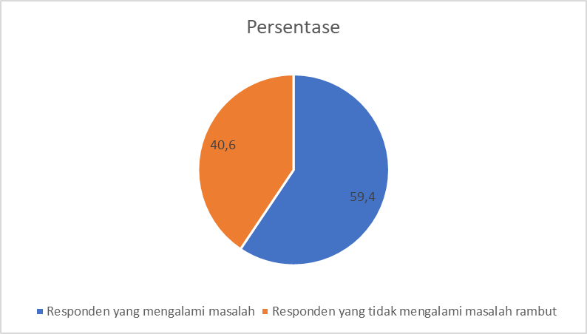

Figure 1. Respondents who have hair problems, around the scalp

An analysis was conducted regarding respondents who had dandruff problems and those who did not have dandruff problems

:

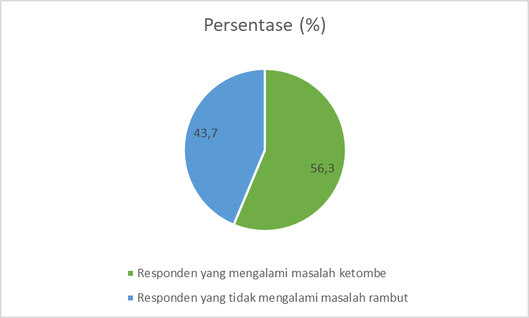

Figure 2 Respondents who have dandruff problems and those who do not have dandruff problems

An analysis was carried out regarding the repeated use of the hijab and the wearing of the hijab which was only used once. The results of the analysis showed that 53, 1% used a single-use hijab and 46.9% used a hijab up to 2 times use.

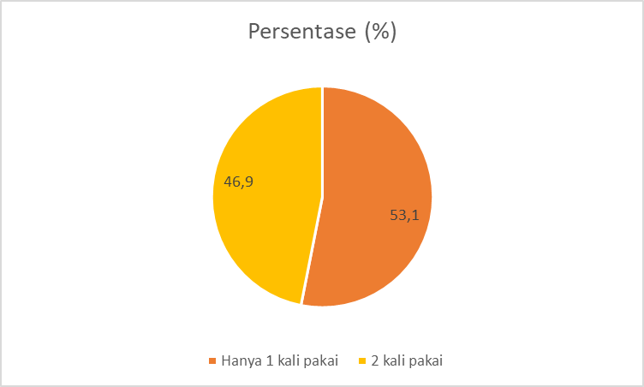

Figure 3 Using repeat hijab with women

Subsequent tests were carried out, namely solutions to scalp problems and hair problems in women who were wearing hijab, namely: 100% shampooing; by using vitamins for hair 28, 1% and creambath in beauty salons as much as 31.3%

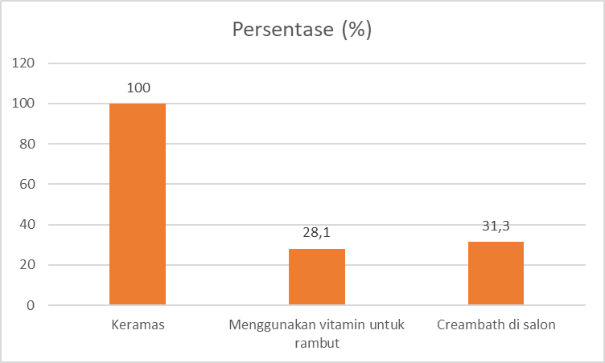

Figure 4 solution with hair and hair skin

There are other complaints faced by women wearing hijab, especially hair loss as much as 6.3%, nodules appear on the scalp if the humidity around the head is high enough as much as 15.6% and there are no complaints as much as 78.1%.

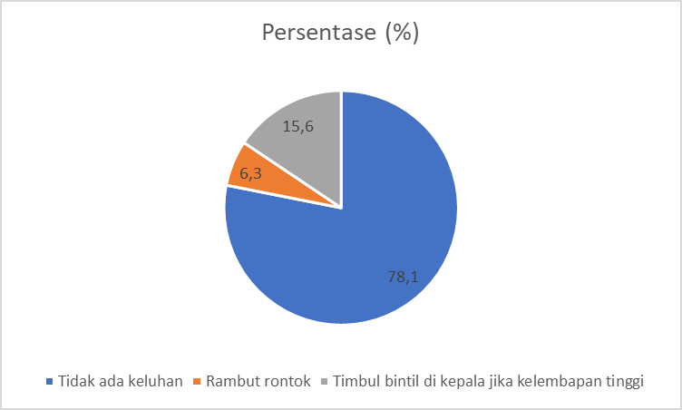

Figure 5 other problem with women hijab

**DISCUSSION**

Based on the data above, it can be seen that 59.4% of women wearing hijab complain of hair problems, scalp, itching and allergies on the scalp and areas around the face and as many as 40.6% have no complaints about this as shown in Figure 1. There are several The thing that causes problems on the scalp, itching and allergies around the face is the presence of fungi such as Candida sp. Candida sp is a fungus which is a normal flora of the body. Candida on the scalp can cause hair loss, scaly and itchy skin. One method of prevention is to wash your hair three times a week (Ariyani, 2009).

An analysis was conducted regarding respondents who had dandruff problems, namely 43.7% had dandruff problems and 56.3% did not have dandruff problems. 43.7% have dandruff problems as shown in Figure 2. Dandruff is one of the dominant problems affecting both women and men. This dandruff problem can be caused by the use of the hijab so that the head of the head is more moist and the repeated use of the headscarf which can sometimes be said to be less clean. The use of hijab can also cause dandruff to increase (Ni'mah, 2011 in Sari, 2018). Dandruff can also be caused by one of the normal flora that is on the skin and head, namely Malassezia fungus.

An analysis was conducted regarding the repeated use of the hijab and the use of the hijab which was only used once. The results of the analysis were 53, 1% used the hijab with a single use and as much as 46.9% used the hijab up to 2 times and some up to 3 times. As shown in Figure 3. The use of a disposable hijab / veil is more recommended because using this one-time hijab can reduce the risk of scalp problems, namely dandruff and hair loss and also the normal flora are still left behind in the hijab that is used repeatedly. This hijab becomes damp when it is used so that it can cause the appearance of microorganisms which can cause the things above such as hair loss, dandruff and the smell of hair and the hijab becomes musty. As many as 46.9% use the hijab repeatedly, in principle, the microorganisms in someone's body are different and the problems experienced by each person are also different.

Subsequent tests were carried out, namely solutions to scalp problems and hair problems in women who were wearing hijab, namely: 100% shampooing; using vitamins for hair as much as 28.1% and creambath in beauty salons as much as 31.3% as shown in Figure 4. There are many ways that women have tried to overcome the scalp problems they experience, namely by washing the main one. Next, use hair vitamins to make your hair stronger. And do other treatments with cream bath at a beauty salon. So respondents have started to understand the use of vitamins and creambath for their hair care. In addition, it can also be done by using a disposable hijab so that the moisture of the hijab and scalp is maintained so that the problem is reduced.

The basic ingredients for the hijab that are generally used by women who wear hijab are varied, namely along with the rapid development of the hijab fashion in the world, namely Cotton as much as 56.3%; voal as much as 18.8%; rawis as much as 37.5%; satin 9.4%; paris as much as 18.1%; corn skin as much as 6.3% and wolfis as much as 6.3% as shown in Figure 6. Respondents used more cotton base material because this hijab is more able to absorb dryness and causes less odor so it is more comfortable and confident to use.

**CONCLUSIONS AND RECOMMENDATIONS**

Based on the results and discussion, it can be concluded that women generally have problems around the scalp and face; The hijab used by the respondents mostly uses cotton-based materials, half of the respondents can use the hijab repeatedly, namely 2-3 times. It is recommended to conduct further research on the problems surrounding the scalp and face with a larger and wider scope in order to design a cloth that can be friendly to the scalp and faces of women who wear hijab. The majority of respondents have been able to treat their hair problems but need regular and correct treatment in this hair problem.

**DAFTAR PUSTAKA**

Abdala, Mai Ali., Sara Abdel., Seid Mohammed Ahmed., Imad Eldin Mohamed Tag Eldin. 2015. Isolation and Identification of Some Microorganisms that cause Abnormal Hair Loss (Baldness). International Journal of Science and Research (IJSR) Vol. 6 No. 12. P. 1973-1982.

Alghamdi, Salma A., Haya A. Alotaibi, Munira Z. Al Subai, Prof. Suaad S. Al Wakeel. 2018. Isolation and Identification of microbial and fungal flora from female hair samples in Riaydh Saudi Arabia.

Amelia, Yola. Rostamailis., Rosalinda, Linda. 2017. Pemanfaatan Kecambah Tauge Untuk Mengatasi Kerontokan Rambut Wanita Berlilbab. E-Journal Home Economic and Tourism. Vol. 14 No. 1.

Ariyani. Sri, Sinto Dewi. Ratih Haribi. 2009. Daya Hambat Sampo Anti Ketombe Terhadap Pertumbuhan C. albicans Penyebab Ketombe. *Jurnal* *Unimus*. Vol. 2 No. 2. P. 7-10.

Sari, Dwi Lukita. Yenni Desilia Indahsari, Lukluk Afifatul Umroh, Hadi Nur Romadhon, Lisa Tri Agustin, Dias Putri Wardanasari, Septiani, Rama Syailendra Hadi, Ni Made Krisantina Shandra, Vindia, Khendy Aksandra dan Andi Hermansyah. 2018. Perilaku Pengguna Hijab dalam Mengatasi Masalah Rambut. *Jurnal Farmasi dan Ilmu Kefarmasian Indonesia*. Vol.5 No. 2. P. 93-98.

Y. Liu., X. Ren., J. Liang. (2015) Antibacterial modification of cellulosic materials. Bio Resources, 10(1): 1964-1985.

